**Software Design Document**

**for 200 mm Factory Automation Project**

**Prepared By : Ramkumar M**

**HiCore Software Technologies Private Limited**

**Version: 1.0**

**Table of Contents**

**1. Introduction 6**

**1.1. Purpose of the Document 6**

**1.2. System Scope 6**

**2. System Overview 6**

**2.1. System Objectives 6**

**2.2. Overall System Description 7**

**2.3. System Context Diagram 8**

**2.4. Key Stakeholders and Interactions 9**

**2.5. High-Level System Capabilities 10**

**3. System Architecture Design 11**

**3.1. Architecture Overview 11**

**3.2. Logical Architecture 12**

**3.3. Deployment Architecture 14**

**3.4. Component Interaction Overview 15**

**3.5. Technology Stack & Frameworks 15**

**3.6. Design Constraints & Assumptions 16**

**3.7. High-Level Architecture Diagram Explanation 16**

**4. Detailed Module Design 17**

**4.1. HSMS Communication Module 17**

**4.2. SECS-II Processing Module 18**

**4.3. GEM Core – Events, Reports & Alarms 19**

**4.4. Recipe Management Module 21**

**4.5. Remote Command Processing 22**

**4.6. Variable Data & VID/SVID Handling 23**

**4.7. Equipment Adapter Layer 23**

**4.8. Simulator / Test Mode Support 25**

**4.9. Logging & Diagnostics 25**

**4.10. Configuration Management 26**

**5. Data Design 27**

**5.1. Data Model Overview 27**

**5.2. VID / SVID Data Model 28**

**5.3. Event & Report Model (CEID / RPTID) 29**

**5.4. Recipe Data Model 30**

**5.5. Log & Audit Data Structures 32**

**5.6. Database / File Storage Structure 32**

**5.7. Data Flow Diagrams 33**

**6. Interface Design 34**

**6.1. Host Communication Interface (HSMS / SECS-II) 34**

**6.2. Equipment Adapter Interfaces 35**

**6.3. Interface Protocols and Message Formats 36**

**7. Communication Error Handling 37**

**7.1. Communication Error Handling 37**

**7.2. Spooling, Replay & Message Recovery 37**

**7.3. Equipment Fault Handling 39**

**7.4. Fail-Safe and Recovery Scenarios 39**

**7.5. Error Logging and Notification Strategy 40**

**8. Security & Access Control 41**

**8.1. Security Objectives 41**

**8.2. Network & Communication Security 42**

**8.3. Authentication & Authorization 42**

**8.4. Security Logging and Auditing 43**

**9. Performance & Scalability 44**

**9.1. Performance Targets 44**

**9.2. Connection Handling Capacity 44**

**9.3. Scalability Considerations 45**

**9.4. Optimization Strategy 45**

**10. Testing & Validation Strategy 46**

**10.1. Test Objectives 46**

**10.2. Unit & Component Testing 46**

**10.3. Integration Testing 47**

**10.4. Performance Testing 47**

**10.5. Conformance Testing 48**

**10.6. Acceptance Criteria 48**

**11. Deployment & Maintenance 49**

**11.1. Deployment Architecture 49**

**11.2. Installation & Upgrade Procedure 50**

**11.3. Backup & Restore Strategy 50**

**11.4. Monitoring & Health Checks 51**

**11.5. Maintenance & Support Guidelines 51**

**12. Appendices 52**

**12.1. Architecture Diagrams 52**

**12.2. Sequence Diagrams 53**

**12.3. Class Design 54**

**12.4. Glossary 57**

**12.5. Future Enhancements 59**

**Version History**

|  |  |  |
| --- | --- | --- |
| **Version** | **Description** | **Date** |
| **1.0** | **Initial Draft** |  |

# **Introduction**

## **Purpose of the Document**

The purpose of this System Design Document (SDD) is to describe the technical design, architecture, and internal structure of the GEM-200 Equipment GEM Controller. This document explains how the system is organized, how its components interact, and how the design satisfies the functional requirements defined in the GEM-200 Software Requirements Specification (SRS).

## **System Scope**

The GEM-200 Controller System is designed to provide standardized communication and automation behaviour for 200 mm semiconductor manufacturing equipment. Its primary scope includes implementing GEM-compliant communication, control, monitoring, and data-exchange capabilities that allow the equipment to integrate smoothly with factory Host systems.

The system covers the design and implementation of the GEM communication layer (HSMS/SECS-II), GEM core functions such as events, alarms, reports, remote commands, recipe handling, and data collection, along with supporting services such as logging, configuration management, security, diagnostics, and simulation support.

# **System Overview**

## **System Objectives**

* + 1. The primary objective of the GEM-200 Controller is to enable reliable and standardized communication between 200 mm semiconductor equipment and factory Host systems in alignment with SEMI GEM standards.
    2. The system is intended to provide consistent monitoring, control, and data-exchange behaviour so that equipment operates safely, transparently, and predictably in an automated production environment.
    3. Ensure full GEM-compliant communication using HSMS-SS and SECS-II protocols.
    4. Provide standardized handling of alarms, events, reports, and variable data
    5. Support secure and controlled execution of Host-issued remote commands.
    6. Enable recipe transfer, validation, storage, and activation for production processes.
    7. Maintain accurate logging, diagnostics, and traceability of system operations and communication.
    8. Allow integration with different equipment platforms through a configurable Equipment Adapter layer.
    9. Provide reliability features including fault detection, recovery, and safe behaviour under abnormal conditions.
    10. Support deployment across multiple tools while maintaining compliance, performance, and ease of maintenance.

## **Overall System Description**

* + 1. The GEM-200 Controller is a software system positioned between the semiconductor equipment and the factory Host system
    2. It implements SEMI GEM standards so the Host can monitor, control, and exchange production information with the equipment in a standardized manner.
    3. The controller communicates with the Host using HSMS-SS / SECS-II and communicates with the equipment through a dedicated Equipment Adapter layer.
    4. This separation ensures that the GEM-200 Controller remains independent of specific PLCs, control systems, or hardware implementations.
    5. Establishes and manages HSMS-SS communication sessions with the Host.
    6. Processes SECS-II messages including commands, queries, reports, acknowledgements, and protocol responses.
    7. Manages GEM communication and control state models in accordance with SEMI standards.
    8. Handles alarms, events, and reports so the Host can monitor and track equipment conditions.
    9. Provides access to variable data (VID / SVID) for status monitoring, reporting, and data collection.
    10. Supports controlled execution of remote commands while enforcing safety and state-based restrictions.
    11. Manages recipe upload, download, validation, storage, and activation.
    12. Maintains detailed logs of communication, system events, and operations for diagnostics and traceability.
    13. Supports optional simulation and test environments for engineering, troubleshooting, and integration testing.

## **System Context Diagram**

The System Context Diagram shows how the GEM-200 Controller interacts with external systems and major stakeholders. It illustrates the boundaries of the GEM-200 Controller and identifies all primary inputs, outputs, and communication flows.

At a high level, the GEM-200 Controller sits between the Factory Host System and the Equipment Control System (PLC/Controller). It also optionally interacts with engineering tools and operator interfaces.

**Main interactions shown in the diagram:**

* + 1. Factory Host System → GEM-200 Controller

HSMS/SECS-II communication for commands, events, alarms, recipes, and data collection.

* + 1. GEM-200 Controller → Equipment Control System (Equipment Adapter Layer)

Exchange of equipment status, variables, alarms, events, and execution of control commands.

* + 1. Operator / Engineering UI (Optional)

Monitoring, diagnostics, simulation controls, and troubleshooting.

* + 1. Log and Configuration Storage

Persistent storage used for logs, configuration files, and recipe data.

* + 1. Test / Simulation Tools (Optional)

Host simulator or equipment simulator used during engineering or FAT testing.

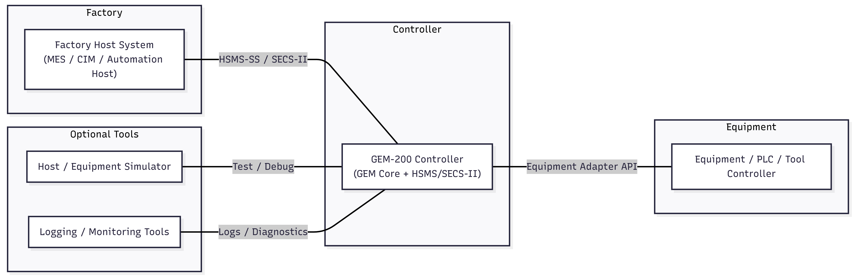

**Figure 1.1 – System Context Diagram**

## **Key Stakeholders and Interactions**

The GEM-200 Controller interacts with multiple stakeholders across engineering, operations, and factory automation. Each stakeholder relies on the system for specific functions and information.

* + 1. **Factory Automation (FA) / Host System Team**
* Sends commands, recipes, and data collection requests.
* Receives alarms, events, production data, and status information.
  + 1. **Equipment OEM Engineering Team**
* Implements GEM features and interfaces.
* Performs debugging, testing, and upgrades.
  + 1. **Equipment Control / PLC Software Team**
* Supplies VID/SVID values, alarms, and system status.
* Executes commands dispatched through the GEM Controller.
  + 1. **Equipment Operators / Technicians**
* View alarms, events, communication status, and logs.
* Assist during equipment installation, qualification, and support.
  + 1. **Customer QA / Process Engineering Team\**
* Validates event reports, recipes, trace data, and performance.
  + 1. **Service & Support Engineers**
* Analyze logs, replay issues, and verify Host communication.

|  |  |
| --- | --- |
| **Stakeholder** | **Interaction with GEM-200 Controller** |
| Factory Host System | Sends commands, receives reports, alarms, and production data |
| OEM Engineering | Develops, configures, and maintains GEM features |
| PLC / Equipment Control | Provides status, executes commands, sends events/alarms |
| Operators | Monitor status and diagnostics (optional UI) |
| QA / Process Engineers | Validate functionality and compliance |
| Service Engineers | Troubleshoot using logs, simulators, and tools |

## **High-Level System Capabilities**

The GEM-200 Controller provides a standardized interface that allows a factory Host system to monitor, control, and integrate the equipment into automated semiconductor production. At a high level, the system delivers the following capabilities:

* + 1. **Standards-Compliant GEM Communication**

Supports HSMS-SS and SECS-II protocols to enable reliable Host–Equipment connectivity based on SEMI E30/E37/E5.

* + 1. **Equipment Status Monitoring**

Reports operating states, conditions, alarms, and diagnostic messages in real time.

* + 1. **Event and Report Handling**

Generates configurable collection events (CEIDs) and associated reports (RPTIDs) with the required VID/SVID data.

* + 1. **Alarm Management**

Detects, logs, and communicates alarm set/clear events and supports alarm queries from the Host.

* + 1. **Variable Data Collection**

Provides access to equipment data variables, including real-time values and trend/trace collection when required.

* + 1. **Remote Command Execution**

Allows the Host to issue authorized equipment commands while enforcing control-state and safety rules.

* + 1. **Recipe Management**

Supports recipe upload, download, storage, validation, and activation aligned with GEM requirements.

* + 1. **Terminal Messaging**

Enables informational communication between Host and operator using GEM terminal services.

* + 1. **Spooling and Recovery**

Retains message history during communication loss and automatically replays data when the connection is restored.

* + 1. **Simulation and Test Support (Optional)**

Provides Host simulator and equipment simulator functionality for integration testing without real equipment.

* + 1. **Logging and Diagnostics**

Maintains detailed logs of communication, alarms, events, and commands for troubleshooting and audits.

* + 1. **Configuration and Maintainability**

Uses structured configuration files and modular components for easy deployment, tuning, and upgrades.

# **System Architecture Design**

## **Architecture Overview**

The GEM-200 Controller shall use a modular, layered architecture that separates communication services, GEM logic, and equipment-specific integration to improve reliability, flexibility, and maintainability.

* + 1. The system shall include an HSMS/SECS communication layer that handles TCP/IP communication, HSMS session control, SECS-II message encoding/decoding, and ensures compliance with SEMI E37 and E5.
    2. The system shall include a GEM Core services layer that manages communication/control state models, events and reports (CEID/RPTID/VID), alarms, remote commands, recipe handling, and terminal services.
    3. The system shall include an Equipment Adapter layer that provides a standardized interface to the PLC/controller, abstracts equipment-specific logic, and enables reuse across different equipment models.
    4. The system shall include configuration, logging, and diagnostics capabilities to manage settings, maintain persistent logs, and support troubleshooting and maintenance activities.
    5. The system shall optionally support engineering and simulator tools (Host simulator, Equipment simulator, diagnostic UI) to enable testing and factory acceptance without live equipment.



**Figure 1.2 - High-Level Architecture Diagram**

## **Logical Architecture**

The GEM-200 Controller is logically organized into independent layers that separate protocol handling, GEM business logic, and equipment integration, ensuring clarity, testability, and modular development.

* + 1. The communication layer shall manage HSMS-SS connections and SECS-II message processing, isolating transport and protocol concerns from GEM logic.
    2. The GEM core layer shall implement state models, alarms, events, reports, recipes, remote commands, terminal services, and other GEM-required behaviors.
    3. The equipment adapter layer shall translate GEM actions into equipment-specific control operations and map real equipment status back into GEM variables and events.
    4. The data management layer shall handle VID/SVID values, CEID-RPTID mappings, configuration files, and recipe storage.
    5. The logging and diagnostics layer shall capture message traces, alarms, events, and system health information for troubleshooting and audits.
    6. The optional simulator layer shall allow Host simulation, equipment simulation, and offline testing without impacting real equipment.
    7. Each logical layer shall communicate only through well-defined interfaces, minimizing dependencies and simplifying maintenance.

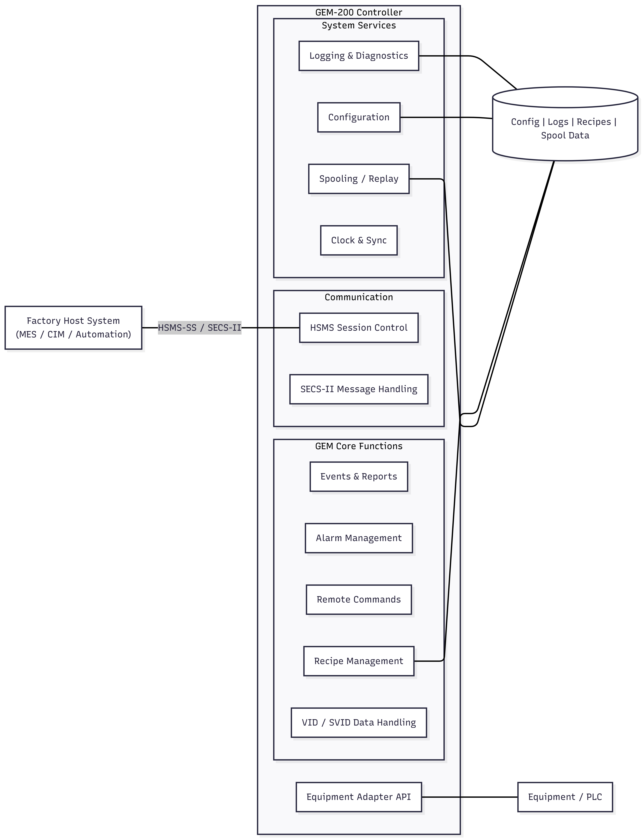

**Figure 1.3 – Logical Architecture Diagram**

## **Deployment Architecture**

The GEM-200 Controller is deployed on the equipment side and operates as a dedicated software service that communicates with the factory Host while integrating with the internal equipment control system.

* + 1. The system shall run on the equipment industrial PC (EPC) or embedded controller provided by the OEM.
    2. The system shall maintain a persistent HSMS-SS connection with the factory Host over the factory automation TCP/IP network.
    3. The system shall communicate with the equipment control system (PLC or motion/process controller) through the Equipment Adapter interface.
    4. The system shall store configuration files, log data, recipes, and operational records locally on the equipment controller.
    5. The factory Host shall connect remotely to the GEM-200 Controller to request status, issue commands, collect events, and monitor alarms.
    6. Internal equipment data such as VIDs, alarms, state changes, and process information shall flow from the control system to the GEM Controller through the Equipment Adapter.
    7. Optional operator or engineering tools shall access the GEM-200 Controller locally or securely over the network for diagnostics, testing, and simulation.
    8. The deployment shall support 24×7 continuous operation and automatically recover communication after system restarts or network interruptions.
    9. Production communication shall be isolated from engineering tools to ensure safety and prevent unintended command execution.

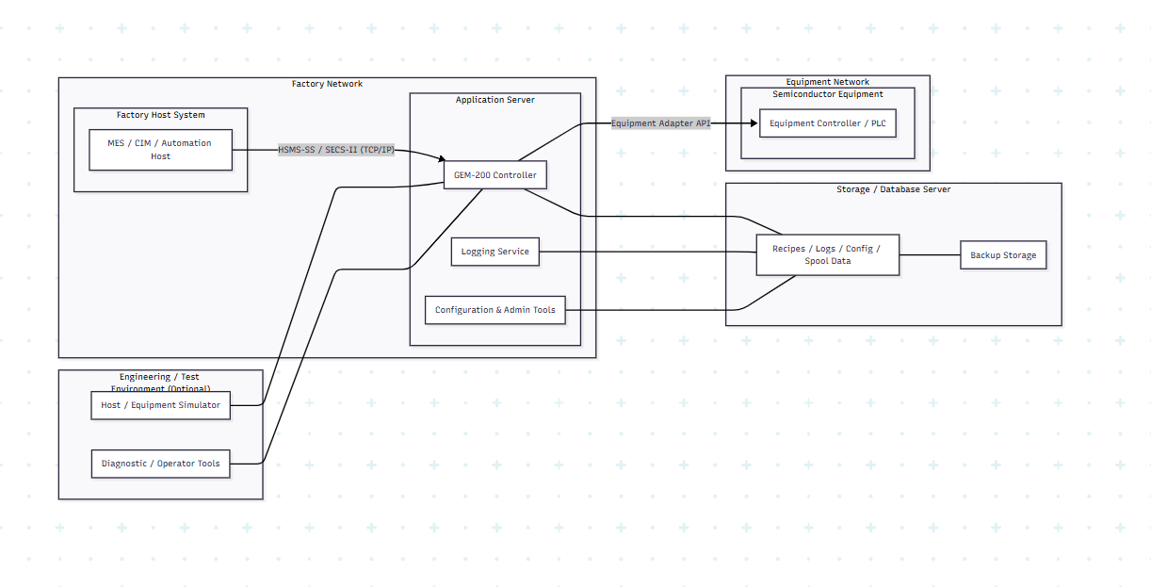

**Figure 1.4 - Deployment Diagram**

## **Component Interaction Overview**

The component interaction overview describes how internal modules of the GEM-200 Controller collaborate to process Host requests, manage GEM behavior, and interact with the equipment.

* + 1. The communication layer shall receive HSMS/SECS-II messages from the Host and forward valid messages to the GEM core services.
    2. The GEM core shall interpret incoming messages, apply GEM rules, and determine whether they relate to status queries, remote commands, alarms, events, reports, or recipes.
    3. The GEM core shall interact with the equipment adapter whenever equipment data, commands, or status feedback are required.
    4. The equipment adapter shall translate GEM operations into equipment-specific controller calls and return real-time responses (VIDs, states, alarms, results) back to the GEM core.
    5. When an event, report, or alarm condition occurs, the GEM core shall format the data and instruct the communication layer to send the appropriate SECS-II messages to the Host.
    6. The data management components shall provide stored definitions (VIDs, CEIDs, RPTIDs, recipes, configuration values) used during runtime processing.
    7. The logging subsystem shall record message flows, command execution, state transitions, alarms, and diagnostic information during each interaction flow.
    8. Optional simulator components shall intercept or mimic equipment responses when simulation mode or testing mode is enabled.
    9. All module interactions shall follow defined APIs and shall not bypass layer boundaries, ensuring predictable and maintainable behavior.

## **Technology Stack & Frameworks**

The GEM-200 Controller is implemented using a robust and maintainable technology stack selected for reliability, performance, and long-term support.

* + 1. The system shall be developed using a modern programming language suitable for industrial control environments (for example: C#, C++, Java, or Python — finalized per OEM requirement).
    2. The system shall run on an industrial-grade operating system such as Windows, Linux, or an OEM-approved embedded OS.
    3. The communication layer shall use standard TCP/IP networking libraries to support HSMS-SS connectivity.
    4. SECS-II encoding/decoding shall be implemented using compliant serialization libraries or validated in-house components.
    5. Configuration data, recipes, and definitions may be stored using structured formats such as JSON, XML, or relational databases, depending on deployment needs.
    6. Logging and diagnostics shall be implemented using industry-standard logging frameworks capable of rotation, filtering, and persistent storage.
    7. Optional UI tools may be built using desktop, web, or embedded UI frameworks approved by the OEM (for example: .NET WinForms/WPF, Web UI, Qt, etc.).
    8. All technology selections shall emphasize long-term maintainability, vendor support, and compatibility with factory IT policies.

## **Design Constraints & Assumptions**

* + 1. The system shall comply with SEMI E30, E37, E5, and E4 standards, and design decisions shall not violate GEM behavior requirements.
    2. The system shall operate primarily in HSMS Passive (Equipment) mode for production environments.
    3. The GEM Controller shall not directly control mechanical motion or safety-critical functions; such operations remain under the equipment control system.
    4. Equipment-specific logic shall be isolated in the Equipment Adapter layer, and the GEM core shall remain hardware-independent.
    5. Network security, authentication rules, and deployment constraints shall follow factory IT and OEM policies.
    6. The design assumes availability of a factory Host capable of GEM communication.
    7. The design assumes that the equipment control system provides reliable APIs or data interfaces for alarms, statuses, VIDs, recipes, and command execution.
    8. Resource limits such as CPU, memory, and storage shall be considered to ensure real-time responsiveness and continuous operation.
    9. Any future feature enhancements shall be incorporated without modifying core GEM compliance behavior, preserving backward compatibility.

## **High-Level Architecture Diagram Explanation**

The high-level architecture diagram illustrates how the GEM-200 Controller interacts with the factory Host, internal equipment systems, and optional engineering tools.

* + 1. The diagram shows the GEM-200 Controller positioned between the factory Host system and the equipment control system, acting as the automation gateway.
    2. The Host connects to the GEM-200 Controller over the factory automation network using HSMS-SS (TCP/IP) and exchanges SECS-II messages.
    3. The GEM Core inside the controller manages events, alarms, reports, remote commands, recipes, and GEM state control.
    4. The Equipment Adapter connects the GEM Controller to the equipment PLC or process controller and translates GEM interactions into equipment-specific operations.
    5. Internal data flows include variable data updates, alarm notifications, event triggers, and status information coming from the equipment to the GEM Core.
    6. Outbound flows include event reports, alarm reports, status responses, and command acknowledgements sent from the GEM Controller to the Host.
    7. Configuration, logs, and recipes are stored locally and accessed by GEM components as required during runtime.
    8. Optional engineering tools (Host simulator, equipment simulator, diagnostic UI) connect to the system in controlled environments for testing and troubleshooting without affecting production.
    9. The diagram highlights clear separation between communication, GEM functionality, and equipment integration, reinforcing modular and maintainable system design.

# **Detailed Module Design**

## **HSMS Communication Module**

The HSMS Communication Module is responsible for establishing and maintaining the communication link between the factory Host and the GEM-200 Controller using HSMS-SS over TCP/IP.

* + 1. The module shall operate primarily in Passive (Equipment) mode, allowing the Host to initiate connections.
    2. The module shall manage HSMS session establishment, maintenance, and termination in accordance with SEMI E37.
    3. The module shall process HSMS control messages such as Select, Deselect, Linktest, Reject, and Separate.
    4. The module shall implement session timers (T3, T5, T6, T7) and trigger appropriate actions when timeouts occur.
    5. The module shall support byte-level message framing and deframing to ensure complete and correct message delivery.
    6. The module shall forward validated HSMS frames to the SECS-II processing module for interpretation.
    7. The module shall detect connection failures, handle reconnections, and ensure stable communication during network disturbances.
    8. The module shall support secure and controlled network connectivity aligned with factory IT policies.
    9. The module shall produce detailed logs for communication activities to support troubleshooting and auditing.

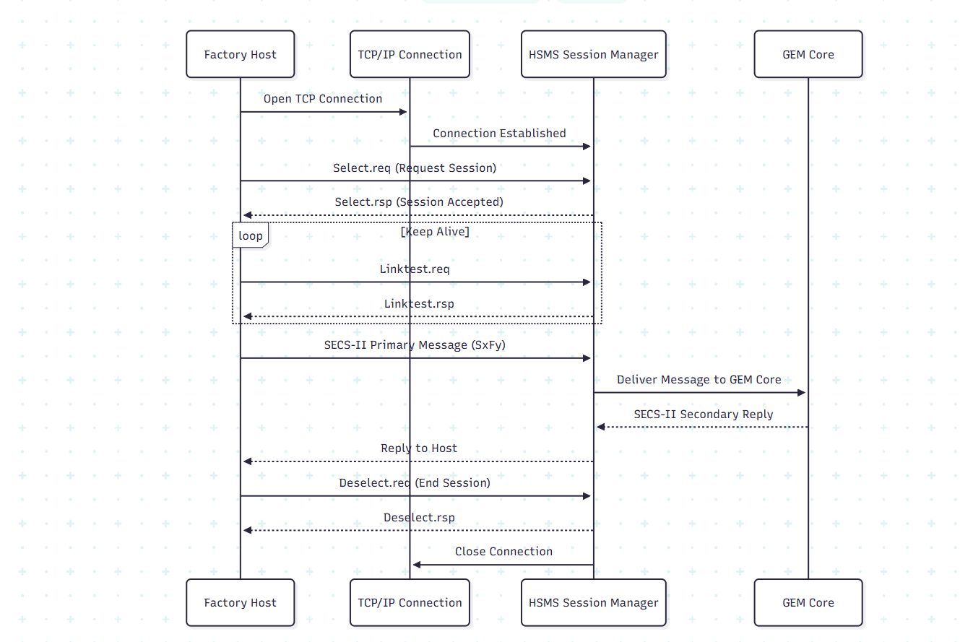

**Figure 1.5 - HSMS Communication Diagram**

## **SECS-II Processing Module**

* + 1. The module shall parse SECS- II message headers and identify stream, function, device ID, system bytes, and W-bit.
    2. The module shall decode SECS-II data items into internal data structures for further processing.
    3. The module shall support all required SECS-II data types, including Lists, ASCII, Binary, Unsigned Integers, Signed Integers, and Boolean values.
    4. The module shall validate message structure, list hierarchy, and data type correctness before passing data to GEM core logic.
    5. The module shall construct compliant SECS-II response messages based on results returned from GEM services.
    6. The module shall generate protocol error responses (S9Fx) when invalid, unsupported, or malformed messages are received.
    7. The module shall support correlation between requests and responses using system bytes and W-bit rules.
    8. The module shall provide APIs to higher-level modules for building SECS-II messages consistently.
    9. All decoded and encoded messages shall be logged for traceability and diagnostics.

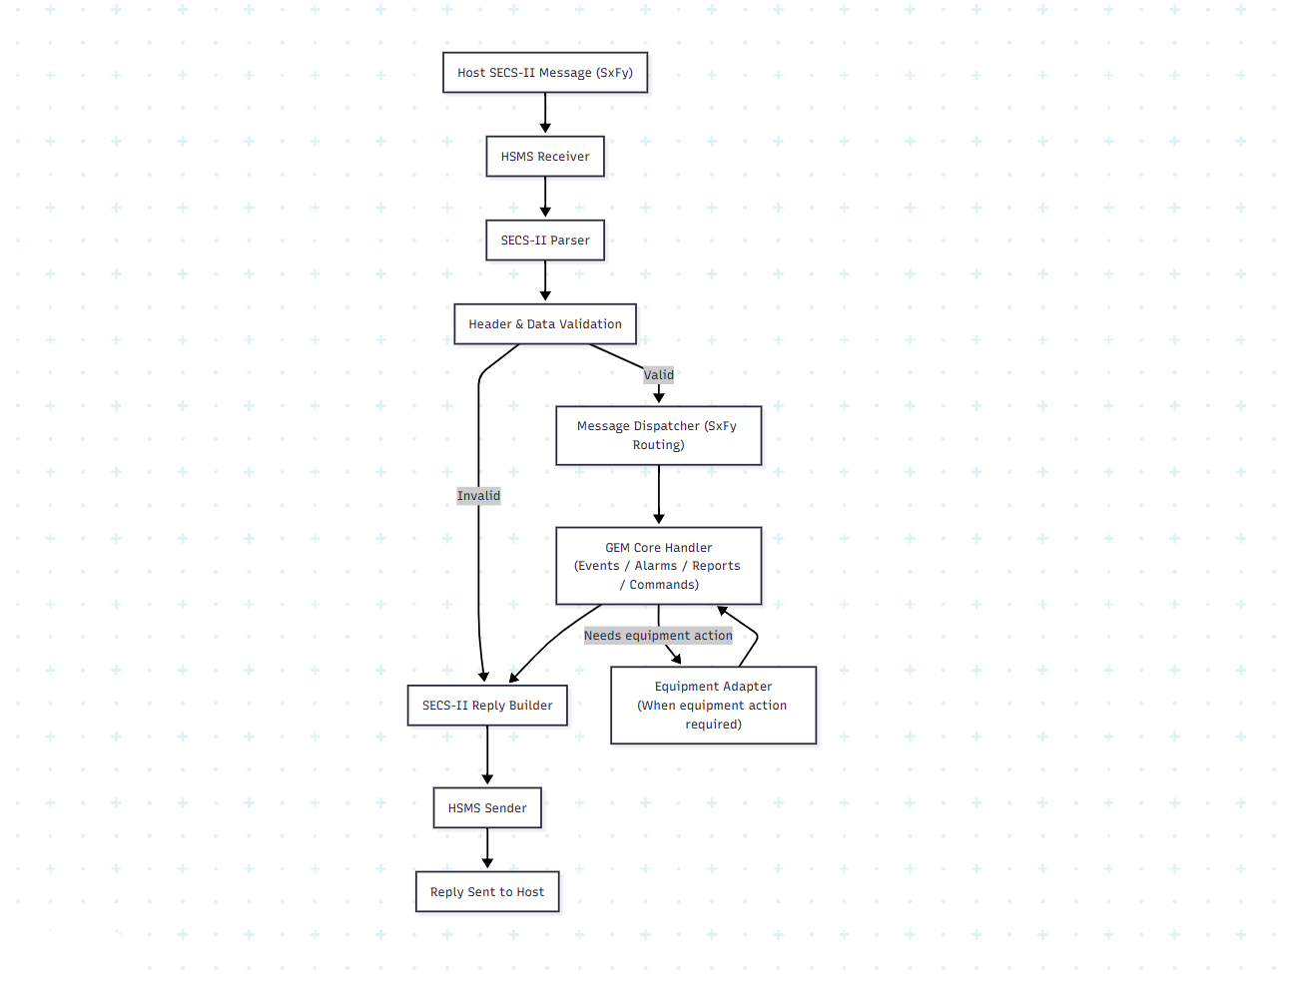

**Figure 1.6 – SECS – II Processing Diagram**

## **GEM Core – Events, Reports & Alarms**

* + 1. The module shall maintain definitions for CEIDs, RPTIDs, and VIDs used in GEM reporting.
    2. The module shall detect GEM-triggering conditions from the equipment or internal state transitions.
    3. The module shall generate S6F11 event reports when configured events occur.
    4. The module shall support dynamic report linking, enabling the Host to configure which variables are included in each event.
    5. The module shall manage alarm definitions, active alarm states, and alarm history.
    6. The module shall generate S5F1 alarm reports when alarms are set or cleared.
    7. The module shall process corresponding acknowledgements such as S5F2 from the Host.
    8. The module shall ensure all reports and alarms include accurate VID data and timestamps.
    9. The module shall enforce GEM rules regarding event enable/disable, reporting control, and sequencing.
    10. All alarm and event activities shall be recorded in the logging subsystem for audit and diagnostics.

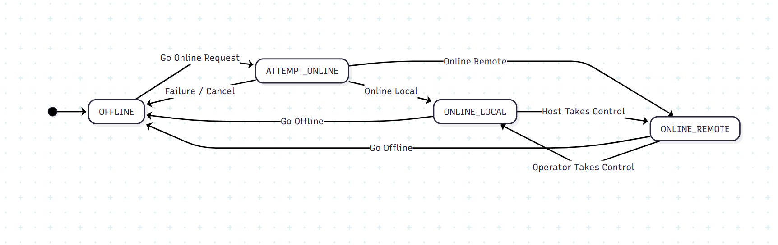

**Figure 1.7 - Communication State Model**

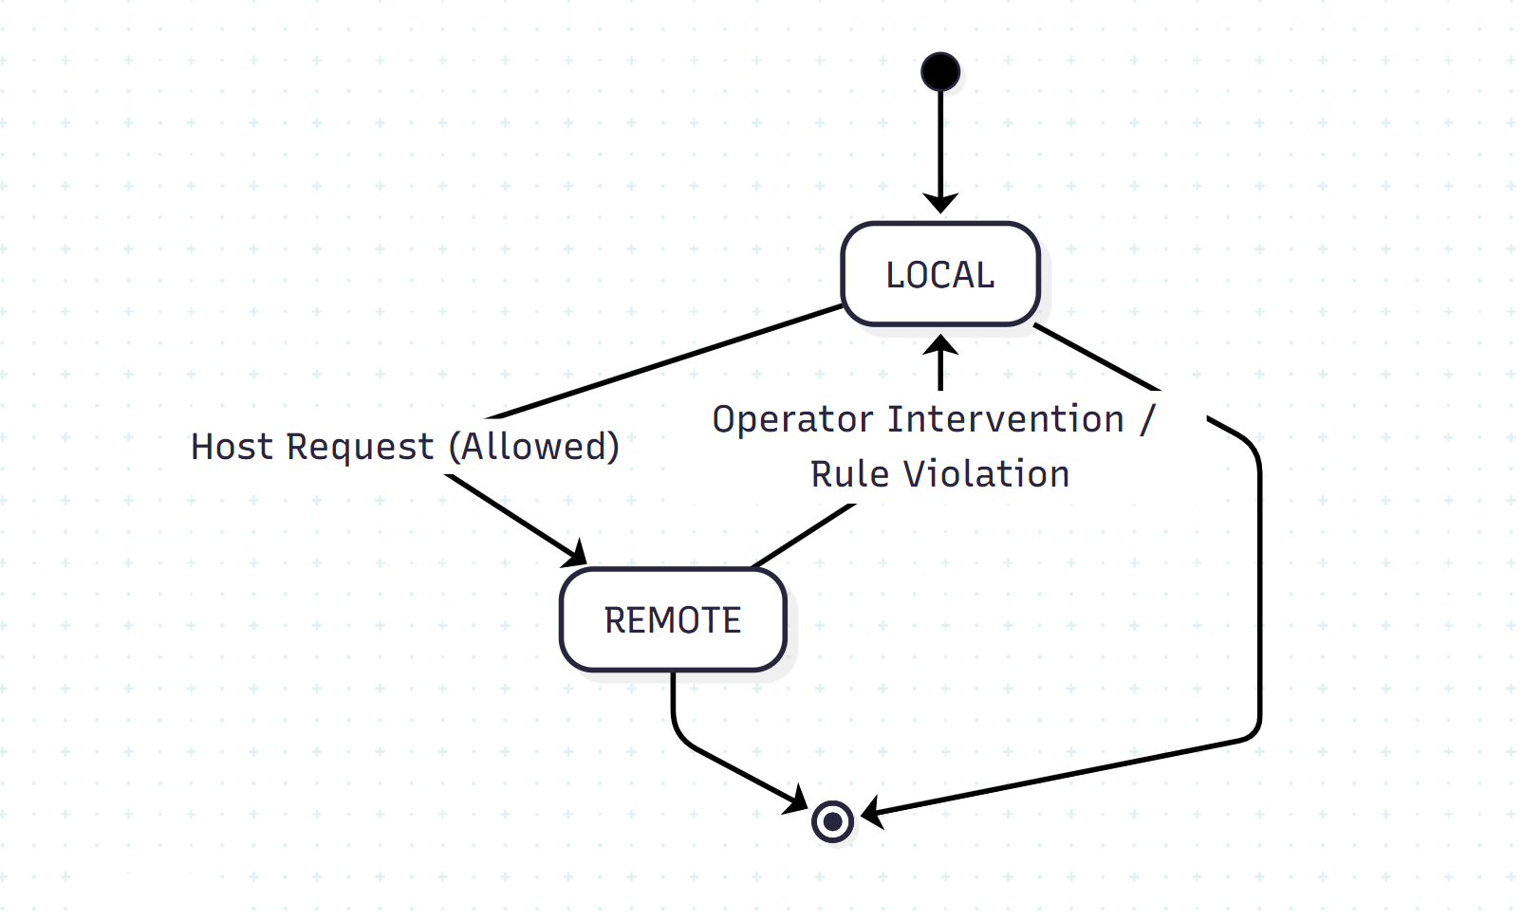

**Figure 1.8 - Control State Model**

## **Recipe Management Module**

The Recipe Management Module handles storage, validation, transfer, and activation of equipment recipes in accordance with GEM requirements.

* + 1. The module shall allow the Host to upload recipes to the equipment.
    2. The module shall allow the Host to download recipes from the equipment.
    3. The module shall support recipe listing so the Host can query available recipes.
    4. The module shall validate recipes for structure and completeness before allowing activation.
    5. The module shall support both structured and unstructured recipe formats as required by the equipment.
    6. The module shall store recipes in persistent storage and maintain version or change identifiers.
    7. The module shall coordinate with the Equipment Adapter to load recipes into the machine when requested.
    8. The module shall prevent recipe activation if equipment state or safety rules do not permit it.
    9. The module shall provide traceability for recipe uploads, downloads, modifications, and activations.
    10. Recipe transactions and operations shall be logged for audit and troubleshooting purposes.

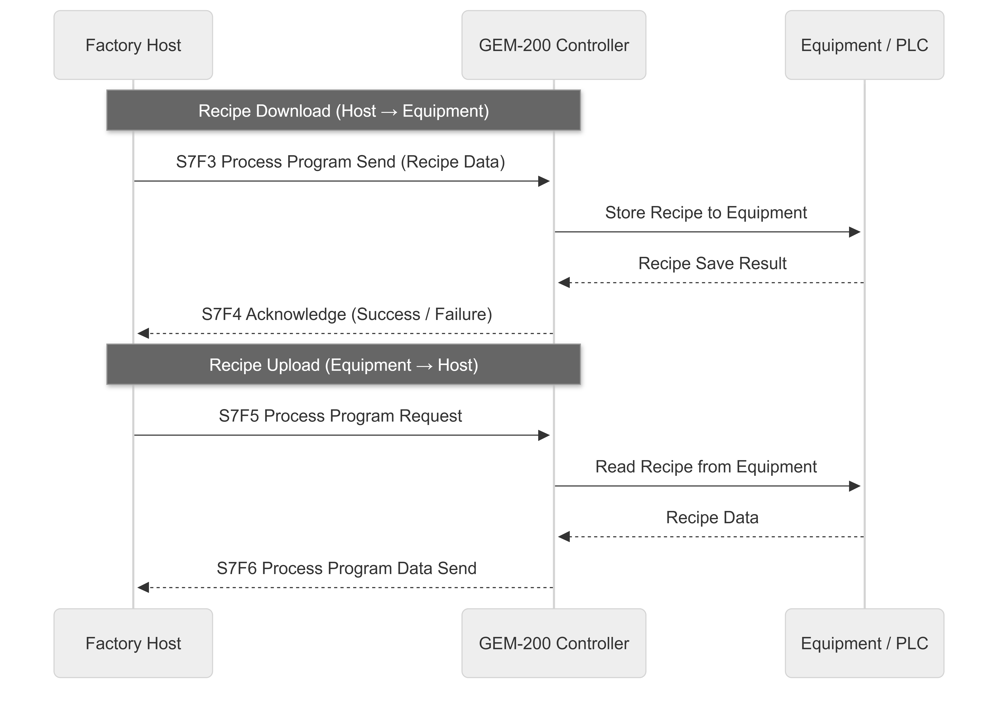

**Figure 1.9 – Recipe management**

## **Remote Command Processing**

The Remote Command Processing module manages Host-initiated control actions and ensures that commands are executed safely and according to GEM rules.

* + 1. The module shall receive and process remote commands issued by the Host using S2F41/S2F42 messaging.
    2. The module shall ensure that remote commands are executed only when the equipment is in the REMOTE control state.
    3. The module shall validate each remote command before execution, including command name, parameter format, and required data.
    4. Invalid, unsupported, or incorrectly formatted commands shall be rejected with appropriate error responses.
    5. The module shall verify communication state and equipment readiness before executing any command.
    6. Valid commands shall be forwarded to the Equipment Adapter for execution on the equipment.
    7. The module shall return execution status and results to the Host using S2F42 responses.
    8. Execution failures, safety restrictions, or equipment errors shall be reported clearly to the Host.
    9. All received commands, execution results, and errors shall be logged for traceability and diagnostics.
    10. The system shall support enhanced or parameterized remote commands where required by SEMI extensions or customer needs.

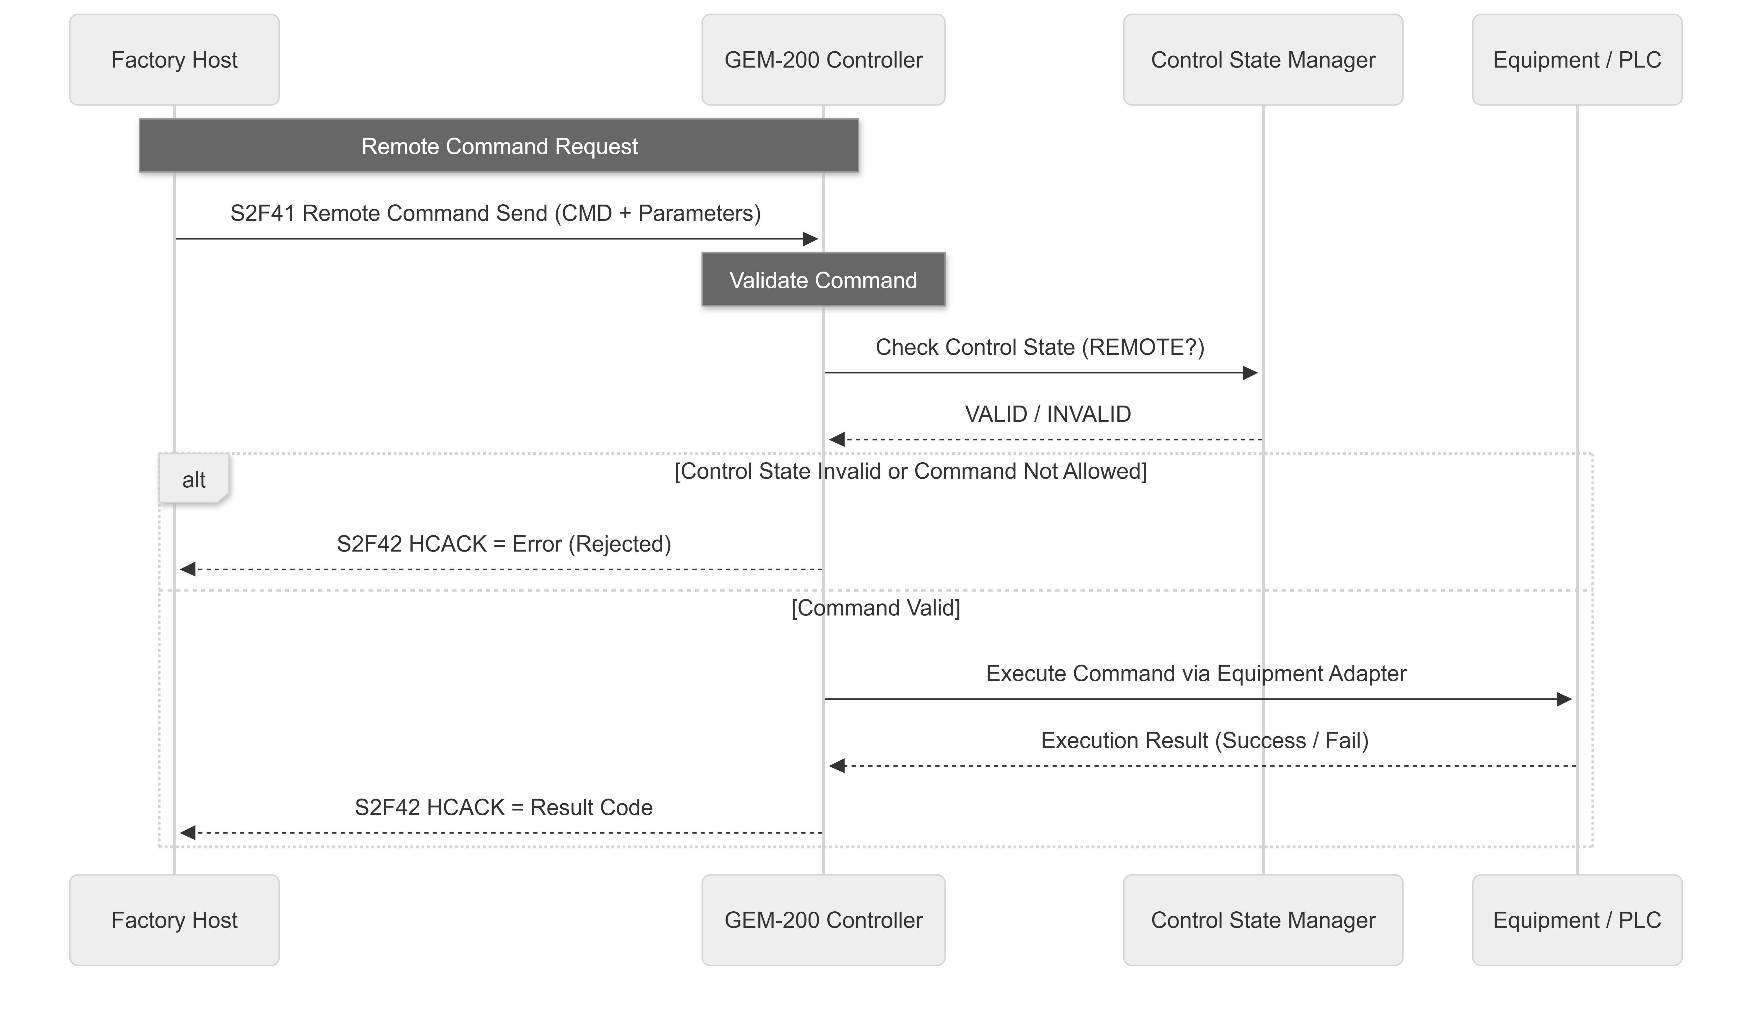

**Figure 1.10 - Remote Command Processing**

## **Variable Data & VID/SVID Handling**

* + 1. The system shall maintain a defined list of Variable IDs (VIDs) and Status Variable IDs (SVIDs) in accordance with SEMI E30.
    2. Each VID and SVID shall include a unique identifier, name, data type, description, and associated equipment source.
    3. VIDs shall represent measurable process or equipment data (e.g., temperatures, pressures, counters, process statuses).
    4. SVIDs shall represent equipment and GEM status information such as communication state, control state, or mode indicators.
    5. Variable definitions shall be configurable and stored in a persistent configuration repository.
    6. The system shall acquire real-time variable values from the equipment via the Equipment Adapter layer.
    7. The system shall ensure the accuracy, consistency, and freshness of variable values before reporting them.
    8. Variable data shall be available for Host requests, event reports, trace collection, periodic reporting, and diagnostics.
    9. The system shall support validation of data type, range, and structure before including variable values in messages.
    10. Variable acquisition mechanisms shall operate without negatively impacting equipment performance or cycle time.
    11. The module shall support trace data collection and periodic sampling using configured VIDs and SVIDs.
    12. Configurable sampling intervals and trace durations shall be supported.
    13. Trace and periodic data collection results shall be transmitted to the Host using standard GEM mechanisms.
    14. Any variable acquisition failure or communication problem shall be detected, logged, and reported where applicable.

## **Equipment Adapter Layer**

The Equipment Adapter Layer provides a standardized interface between the GEM-200 Controller and the underlying equipment control system (PLC, motion controller, embedded controller, etc.).

* + 1. The Equipment Adapter shall isolate equipment-specific logic from core GEM functionality to enable reuse across multiple equipment types.
    2. All interactions with equipment control software or hardware shall occur only through the Equipment Adapter.
    3. The adapter shall provide methods for reading equipment status, process variables, alarms, events, and recipe-related information.
    4. The adapter shall expose functions to execute equipment operations invoked through GEM remote commands, subject to safety and permission rules.
    5. The adapter shall support asynchronous notifications for equipment events that need to trigger GEM CEIDs and reports.
    6. The adapter shall provide mapping logic between equipment internal signals and GEM entities such as VIDs, SVIDs, CEIDs, RPTIDs, and ALIDs.
    7. Communication mechanisms between the adapter and equipment may include TCP/IP, OPC-UA, shared memory, proprietary APIs, or PLC interfaces, depending on equipment design.
    8. The adapter shall include error handling to detect communication failures, invalid responses, or unavailable data.
    9. Equipment Adapter failures shall be logged and shall not cause uncontrolled behaviour in the GEM Core.
    10. The adapter shall provide simulation hooks to allow test mode operation when equipment is unavailable.
    11. The adapter shall support extensibility, allowing new variables, alarms, or events to be added without modifying core GEM components.
    12. Security controls shall prevent unauthorized access to equipment control functions exposed through the adapter.

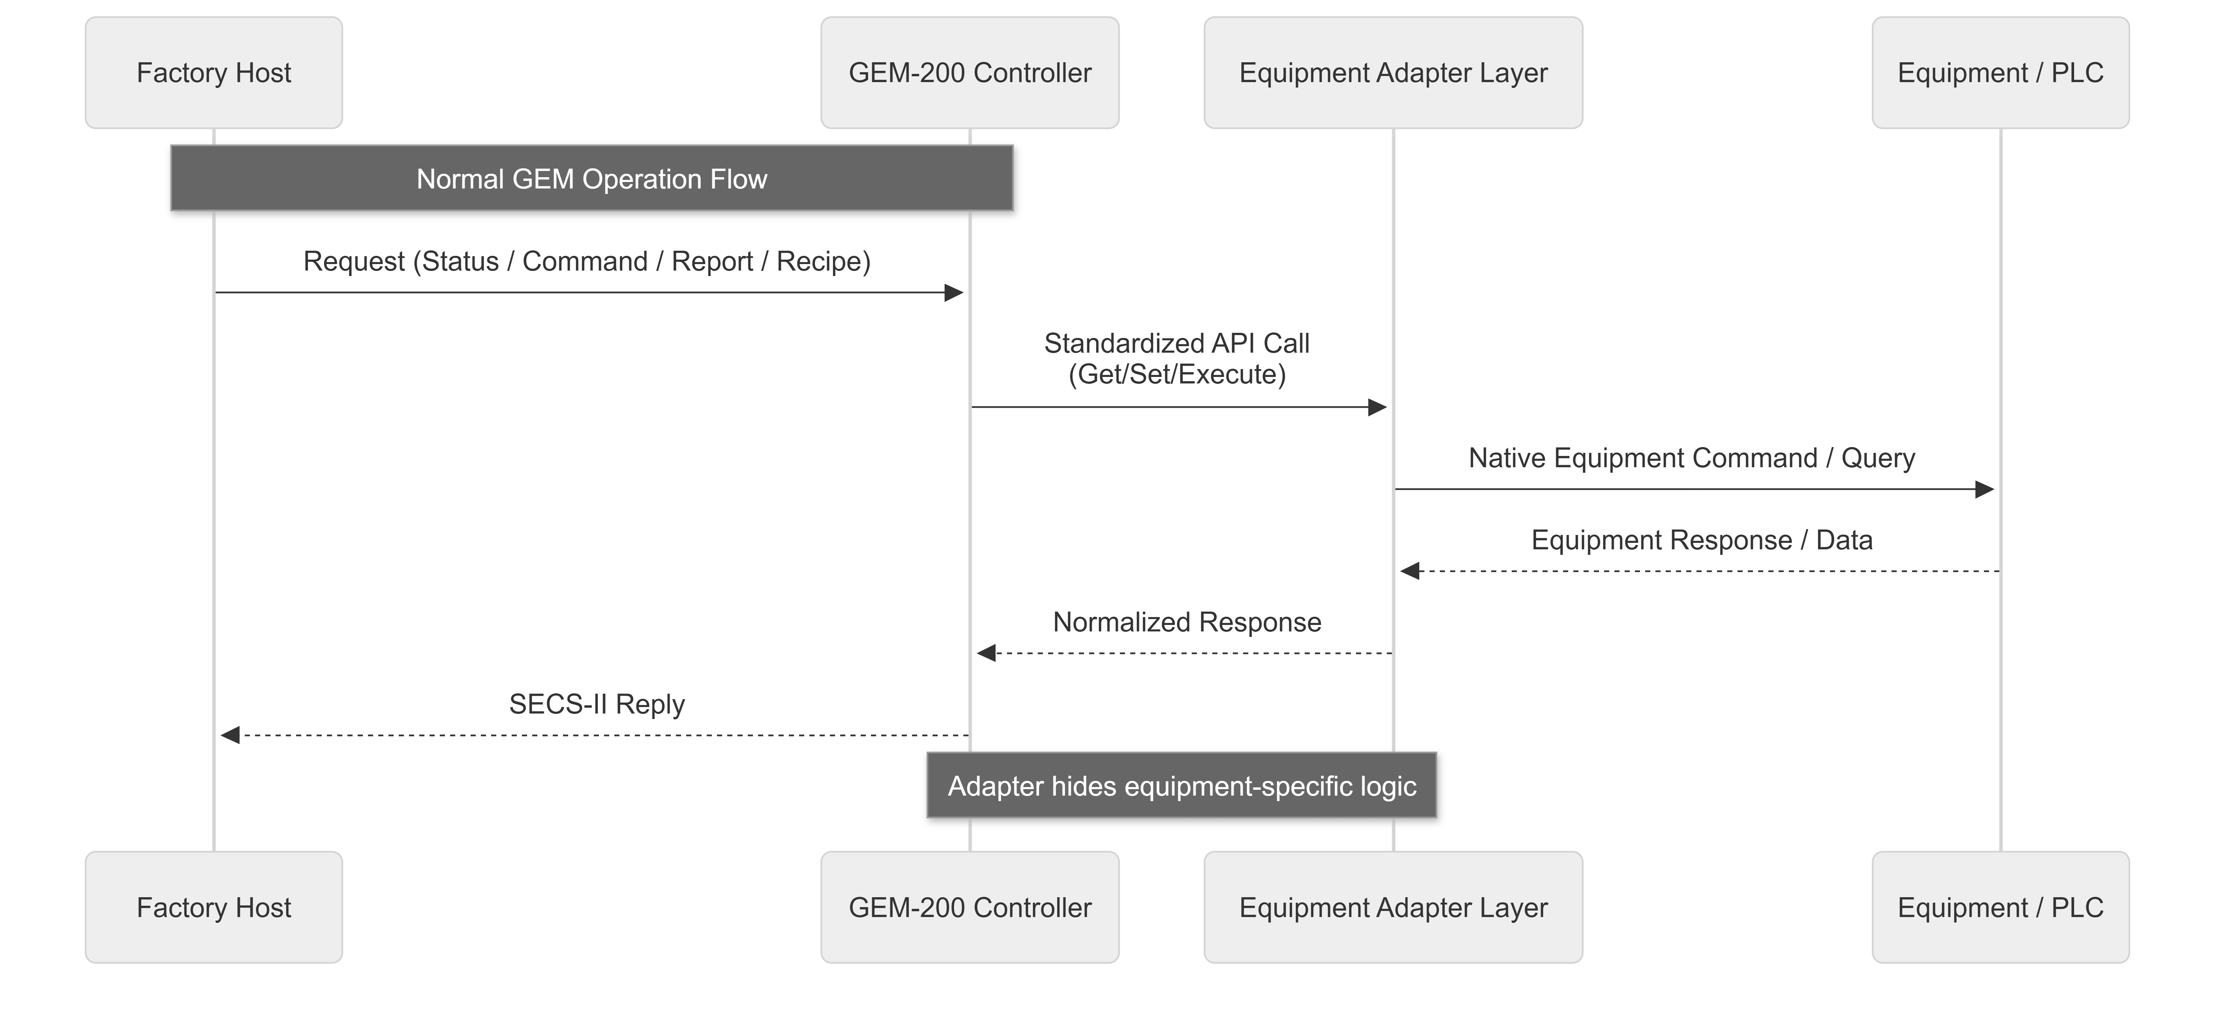

**Figure 1.11 - Equipment Adapter Interface Interaction Diagram**

## **Simulator / Test Mode Support**

The system shall include capabilities to operate in simulator / test mode without requiring live production equipment.

* + 1. Simulator mode shall allow validation of GEM communication, event reporting, alarms, remote commands, and recipes using predefined simulated data.
    2. The simulator shall generate configurable events, alarms, and variable values to mimic real equipment behavior.
    3. Simulator mode shall support Host connectivity using HSMS/SECS exactly as in real production mode.
    4. Switching between simulator mode and real equipment mode shall be configurable and controlled to avoid accidental use in production.
    5. The system shall provide an Equipment Simulator option to emulate equipment responses and states for development and FAT testing.
    6. The system shall provide a Host Simulator option to test GEM functionality when no factory Host is available.
    7. Simulator logs shall clearly indicate simulated operation to avoid confusion with production history.
    8. Simulator behavior shall not alter real equipment settings, recipes, or production data.
    9. Diagnostic tools within simulator mode shall allow step-by-step testing of commands, events, alarms, and data collection scenarios.
    10. The simulator framework shall be extendable to support additional equipment scenarios in future.

## **Logging & Diagnostics**

The system shall provide comprehensive logging and diagnostic capabilities to support troubleshooting, traceability, and audit requirements.

* + 1. The system shall log all significant GEM activities including communication events, alarms, remote commands, reports, and configuration changes.
    2. HSMS/SECS communication logs shall include message direction, timestamp, stream/function identifiers, and transaction results.
    3. Error and exception logs shall capture root-cause details to assist in diagnosing communication, protocol, or equipment issues.
    4. Diagnostic logs shall be categorized by severity (information, warning, error, critical) to simplify analysis.
    5. Logs shall be stored in a persistent format and retained according to configurable retention policies.
    6. The system shall support log rotation to prevent storage overflow and maintain predictable performance.
    7. A diagnostics interface shall be available to review connection status, state models, event triggers, alarms, and recent transactions.
    8. The system shall support filtering and searching logs based on date, event type, equipment state, or message category.
    9. Diagnostic tools shall allow engineers to simulate communication flows, verify protocol behaviour, and replay scenarios when needed.
    10. All logging mechanisms shall be designed such that they do not impact real-time GEM processing performance.
    11. Logs shall support export in standard formats (such as text or CSV) for external analysis or customer records.
    12. Sensitive diagnostic information shall be protected according to system security policies.

## **Configuration Management**

* + 1. All configurable parameters (communication, timers, reports, recipes, logging, and equipment mappings) shall be stored in a persistent configuration repository.
    2. Configuration settings shall be readable at runtime and applied without requiring a restart wherever feasible.
    3. The system shall support default factory configurations along with site-specific customization.
    4. Critical configuration parameters shall be protected from unauthorized modification.
    5. Changes to configuration shall be tracked with timestamp, user, and description of modification.
    6. Communication-related parameters (IP, port, T3/T5/T6/T7 timers, retry limits) shall be configurable.
    7. GEM feature enable/disable options (alarms, events, trace, spooling, reports) shall be configurable.
    8. Variable data definitions (VID/SVID mappings, limits, units) shall be configurable.
    9. Recipe directories, storage policies, and version options shall be configurable.
    10. Logging levels, retention duration, and rotation policies shall be configurable.
    11. Configuration files shall be validated during load to prevent incorrect or unsafe settings.
    12. In case of invalid configuration, the system shall fall back to last known valid configuration and log the condition.
    13. Backup and restore capability shall be available to recover configuration in case of corruption or hardware replacement.
    14. Configuration changes shall not compromise SEMI GEM compliance or system safety.

# **Data Design**

## **Data Model Overview**

The GEM-200 Controller uses structured, SEMI-compliant data models to store and exchange information between the Host, the GEM core logic, and the equipment. The data models ensure consistency, traceability, and predictable behavior during communication, reporting, and control.

* + 1. All GEM entities (VIDs, SVIDs, CEIDs, RPTIDs, alarms, recipes, and logs) shall be represented using well-defined data structures.
    2. Each data model shall include unique identifiers, readable names, data types, and descriptions to support engineering and diagnostics.
    3. Data models shall support mapping between factory Host definitions and equipment-specific internal variables.
    4. The system shall maintain relationships between key GEM data objects, including:
* CEID → RPTID associations
* RPTID → VID/SVID lists
* Alarm → CEID links
* Recipe → Equipment process parameters
  + 1. All persistent GEM data (recipes, configuration, logs, mappings) shall be stored in reliable storage so it remains available across reboots.
    2. Runtime data such as session state, temporary queues, and trace buffers shall be stored in memory with safe recovery handling.
    3. Data validation rules shall ensure correct formats, valid ranges, and supported data types before values are accepted.
    4. Each data model shall support version control where applicable (recipes, configuration, reports) to maintain history and rollback capability.
    5. Access to data models shall be controlled based on user role and system permissions.
    6. Data structures shall be designed for efficient lookups to support low-latency communication and real-time Host interactions.



**Figure 1.12 - Data Model Overview Diagram**

## **VID / SVID Data Model**

* + 1. The GEM-200 Controller maintains structured data models for Variable IDs (VIDs) and Status Variable IDs (SVIDs) in accordance with SEMI E30 and SECS-II data rules.
    2. Each VID and SVID shall be defined with the following attributes:
* **Identifier** (unique numeric ID)
* Name / Label
* **Data Type** (e.g., integer, float, boolean, string)
* Units (if applicable)
* Description
* **Access Type** (read-only, read/write)
  + 1. VIDs shall represent **process-related values**, such as measurements, setpoints, or recorded process data.
    2. SVIDs shall represent **equipment and GEM status information**, such as communication state, control state, or equipment readiness.
    3. The system shall map VIDs and SVIDs to actual equipment data through the Equipment Adapter layer.
    4. VID and SVID values shall be updated in real-time or near real-time to reflect the current equipment condition.
    5. All VID/SVID values shall be validated for correct type, range, and structure before being reported or logged.
    6. VID and SVID data shall be available to the Host for:
* Status requests
* Event and report data
* Trace and periodic data collection
  + 1. The system shall allow configuration of VID/SVID definitions without modifying core GEM logic.
    2. Changes to VID/SVID definitions shall be version-controlled and auditable.

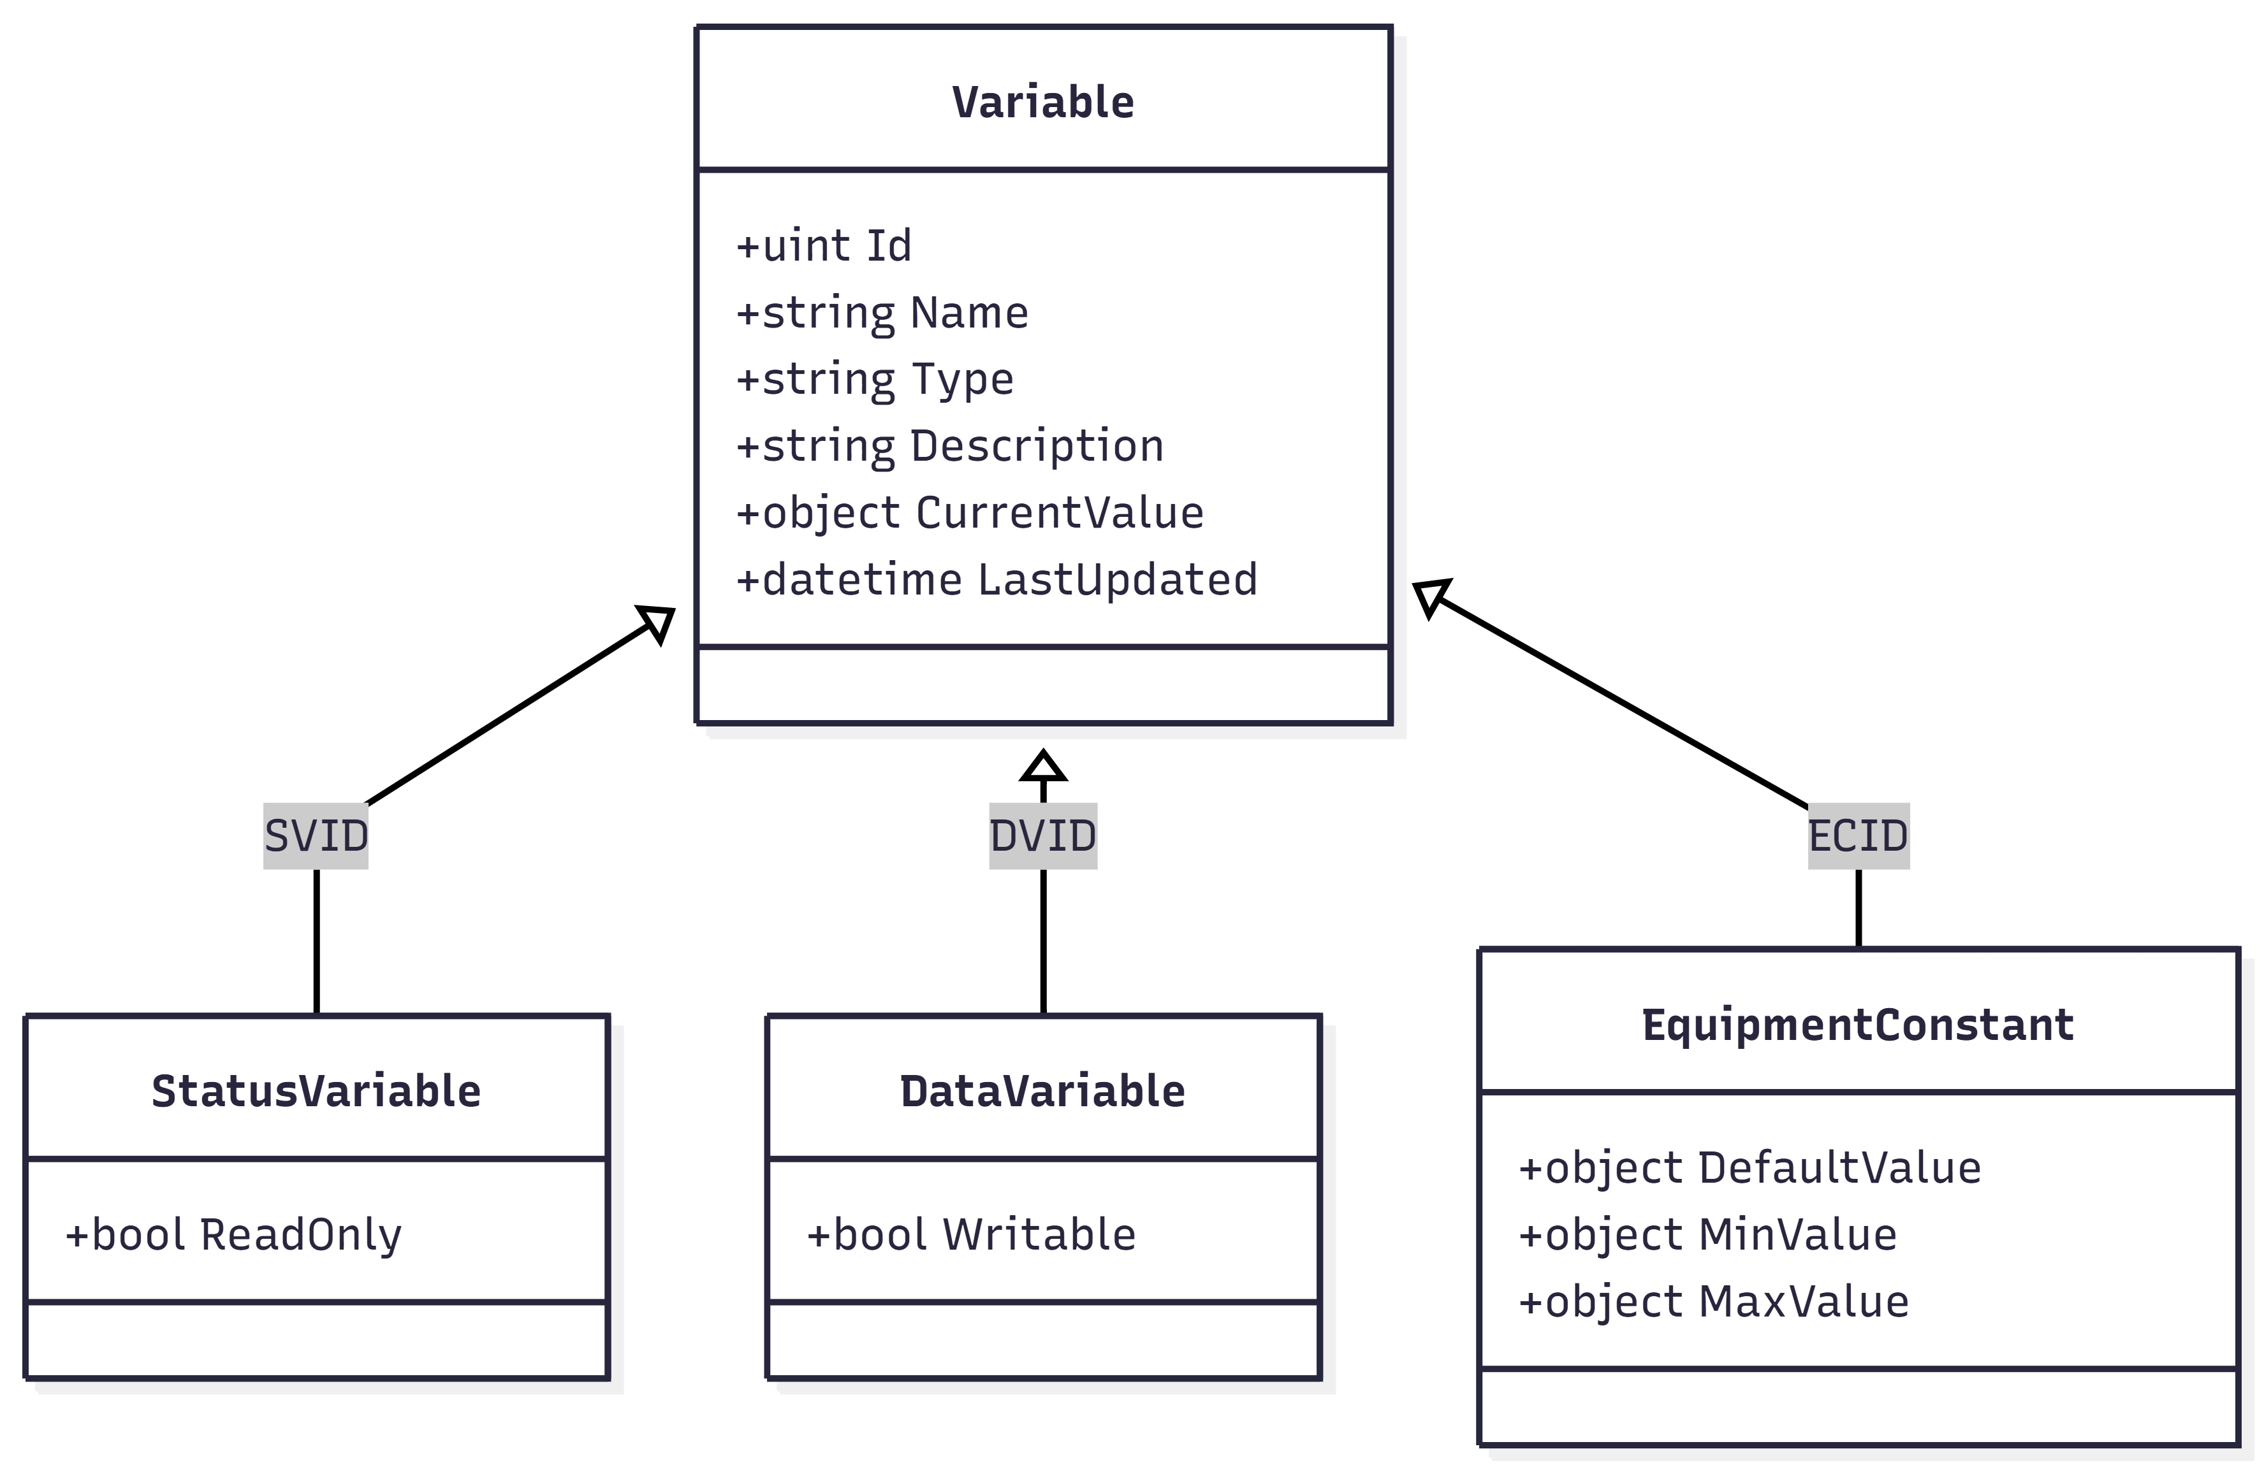

**Figure 1.13 - VID / SVID Data Model**

## **Event & Report Model (CEID / RPTID)**

* + 1. The GEM-200 Controller implements the standard GEM event-report model defined in SEMI E30. Each CEID may be associated with one or more **Report IDs (RPTIDs)**.
    2. The system uses **Collection Event IDs (CEIDs)** to represent significant equipment or process events (e.g., lot start, alarm set, recipe loaded).
    3. Each CEID may be associated with one or more **Report IDs (RPTIDs)**.
    4. Each **Report** consists of one or more **Variable IDs (VIDs/SVIDs)** that provide the data values associated with the event.
    5. CEID, RPTID, and VID relationships shall be configurable without code changes.
    6. Event-to-report links may be dynamically enabled or disabled by the Host where GEM rules permit.
    7. When a configured CEID occurs, the system shall automatically generate an event report and send it to the Host using S6F11 messages.
    8. Reports shall always contain the most recent values of associated VIDs/SVIDs.
    9. The system shall store and manage event/report definitions in persistent configuration storage.
    10. Event reporting shall comply with GEM sequencing, timing, and acknowledgment behavior.
    11. Invalid or incomplete event/report configurations shall be detected and rejected with appropriate logging.

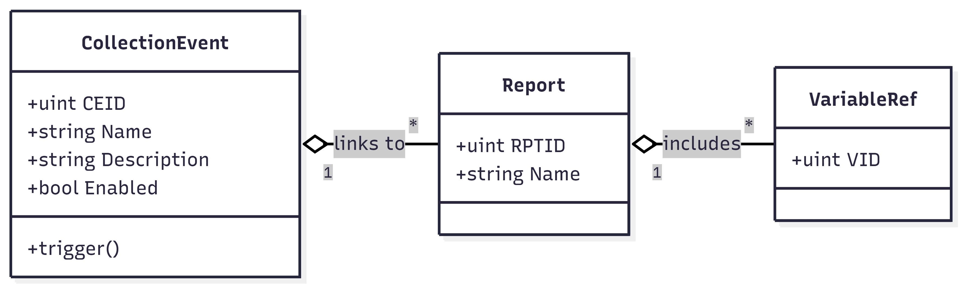

**Figure 1.14 – Event & Report Model Diagram**

## **Recipe Data Model**

* + 1. The GEM-200 Controller shall maintain a structured data model for storing and managing equipment recipes.
    2. Recipes may be stored in either **structured format** (e.g., XML/JSON) or **unstructured/binary format**, depending on equipment requirements.
    3. Each recipe shall have a unique identifier and metadata, including (at minimum):
* Recipe Name
* Version / Revision
* Creation and Modification Timestamps
* Owner / Source (Host or Equipment)
  + 1. The recipe model shall support multiple versions of the same recipe and allow selection of the active version.
    2. All recipe data shall be stored in persistent storage to ensure availability after restart.
    3. The system shall support recipe upload (Host → Equipment) and download (Equipment → Host) in compliance with GEM/SEMI rules.
    4. The recipe model shall maintain integrity during transfer, validation, and activation.
    5. Optional recipe validation rules may be applied by the OEM to ensure correctness before activation.
    6. The system shall track whether a recipe is **active, inactive, or deleted** for audit and traceability.
    7. The recipe data model shall integrate with the Equipment Adapter to provide recipe execution and activation at the equipment level.
    8. Access to recipe data shall be controlled to prevent unauthorized modification or deletion.

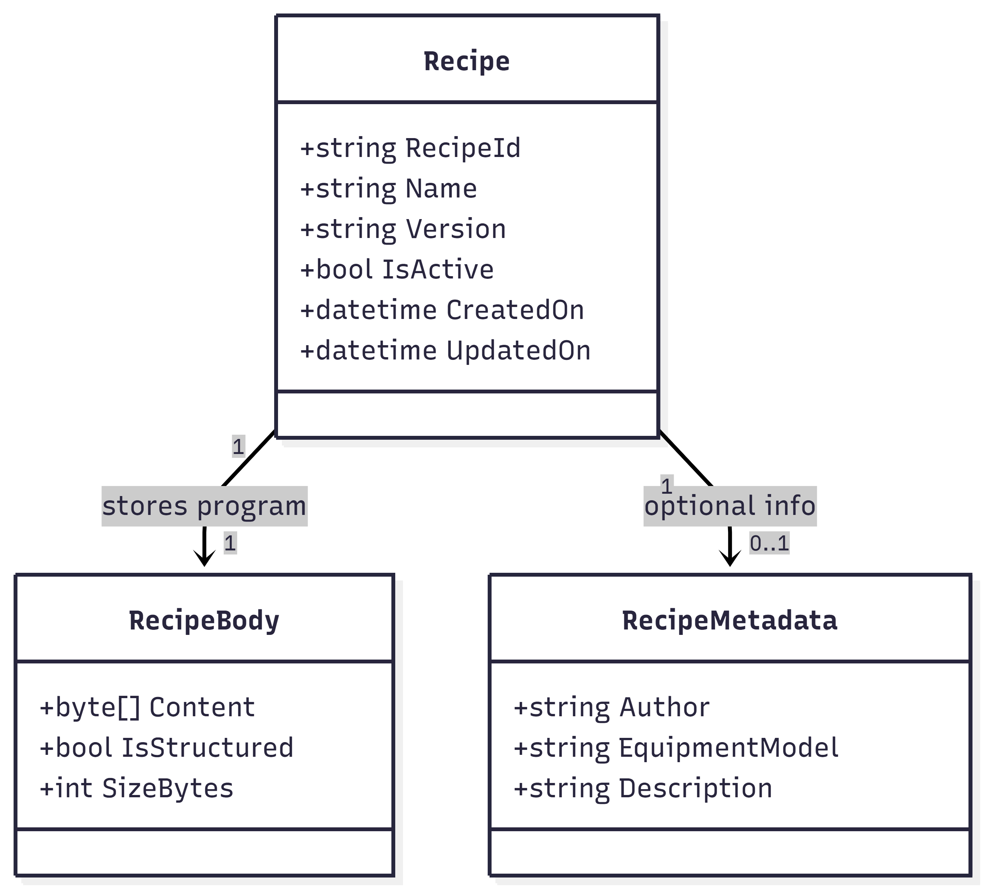

**Figure 1.15 – Recipe Data Model Diagram**

## **Log & Audit Data Structures**

* + 1. The system shall maintain structured logs to record key GEM-200 system activities, including communication, events, alarms, commands, and system operations.
    2. Each log entry shall contain, at minimum:
* Timestamp
* Event / Action Type
* Source (Host, GEM Controller, Equipment)
* Message or Description
* Result / Status
  + 1. Audit logs shall track configuration changes, recipe actions, user activities, and administrative operations for traceability and compliance.
    2. Logs shall be stored in persistent storage and preserved across system restarts.
    3. The logging system shall support configurable retention periods and automatic log rotation.
    4. Critical audit logs shall be protected from unauthorized modification or deletion.
    5. The system shall support filtering and searching logs by time, message type, severity, or equipment identifier.
    6. Log structures shall be designed to support export in common formats (e.g., CSV, JSON, or text) for analysis and audits.
    7. Communication logs shall capture HSMS/SECS message exchanges without exposing sensitive payloads unless explicitly required.
    8. All log and audit records shall support traceability for troubleshooting, diagnostics, and factory audits.

## **Database / File Storage Structure**

* + 1. The system shall use a structured storage approach combining database and file-based storage, depending on the type of GEM data being maintained.
    2. Configuration data (alarms, CEIDs, reports, VIDs, communication settings) shall be stored in structured configuration files or database tables to allow easy modification and versioning.
    3. Recipe files shall be stored in a secure recipe directory with support for both structured (XML/JSON) and unstructured (binary/text) recipe formats.
    4. Log and audit files shall be stored in organized directories with automatic rotation and retention controls.
    5. Spooling data shall be stored in durable local storage so that event/report data can be recovered and retransmitted after communication loss.
    6. Trace and historical data shall be optionally stored for analysis, troubleshooting, and factory reporting needs.
    7. Database/file formats shall be documented to ensure maintainability and portability across deployments.
    8. Data integrity checks shall be applied to prevent corruption, especially for recipes, configuration files, and spooled data.
    9. Secure access controls shall be applied to prevent unauthorized reading or modification of stored files and databases.
    10. Backup and restore mechanisms shall be supported to protect critical GEM configuration, recipe, and log data.

## **Data Flow Diagrams**

* + 1. Data Flow Diagrams (DFDs) illustrate how information moves through the GEM-200 Controller, from the Host interface to internal modules and equipment systems.
    2. The diagrams describe how SECS-II messages, events, alarms, recipes, and variable data are received, processed, stored, and forwarded.
    3. The following high-level flows are represented:
* Host → HSMS Layer → SECS Parser → GEM Core → Equipment Adapter → Equipment
* Equipment → Equipment Adapter → GEM Core → Event/Alarm Engine → Host
* Host → Recipe Manager → Equipment Adapter → Equipment
* GEM Core → Logging Layer → Persistent Storage
* Spooling System → Replay Engine → Host (after reconnect)
  + 1. Each DFD clearly identifies:
* Data inputs and outputs
* Processing modules involved
* Storage locations (logs, recipes, configuration, spooling)
* Interaction paths between Host, GEM Controller, and Equipment
  + 1. The diagrams are intended to support understanding, design review, troubleshooting, and future enhancements.

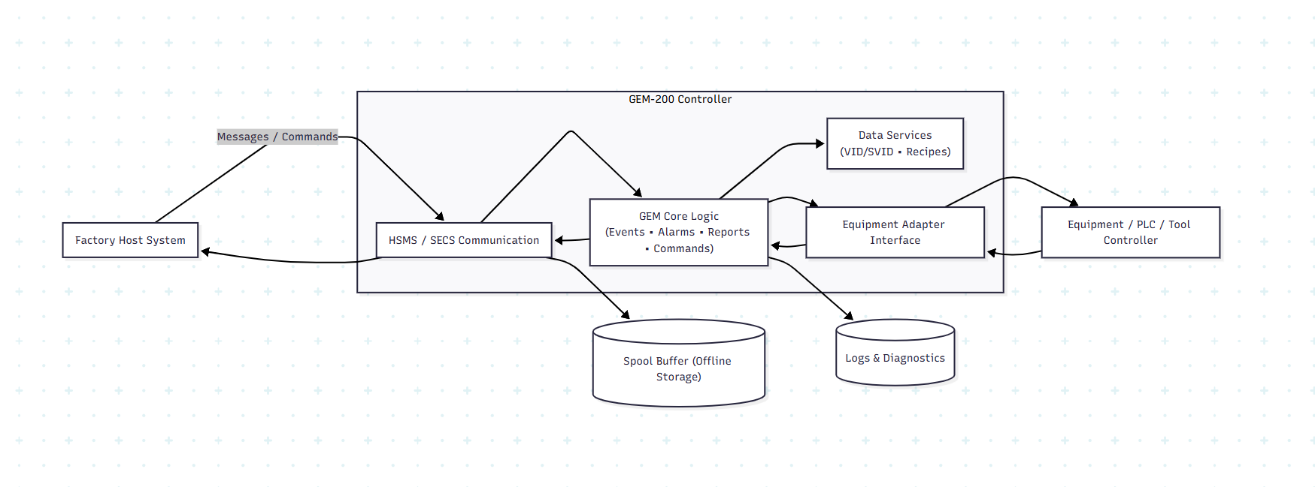

**Figure 1.16 – Data Flow Diagram**

# **Interface Design**

## **Host Communication Interface (HSMS / SECS-II)**

* + 1. The GEM-200 Controller communicates with the factory Host using HSMS-SS over TCP/IP in accordance with SEMI E37.
    2. All Host-Equipment messaging follows SEMI E5 (SECS-II) format, including streams, functions, and data items
    3. The interface supports session establishment, monitoring, error handling, and graceful reconnection when communication is lost.
    4. The Host initiates communication; the equipment operates in Passive Mode during production use.
    5. The interface processes both primary and secondary messages, ensuring correct correlation and timing.
    6. The system enforces GEM communication rules, including message acknowledgments, sequencing, and timeout management..
    7. The interface ensures secure, reliable, and compliant message exchange without impacting equipment operation.
    8. All Host communication activities (sessions, messages, errors) are logged for diagnostics and traceability.

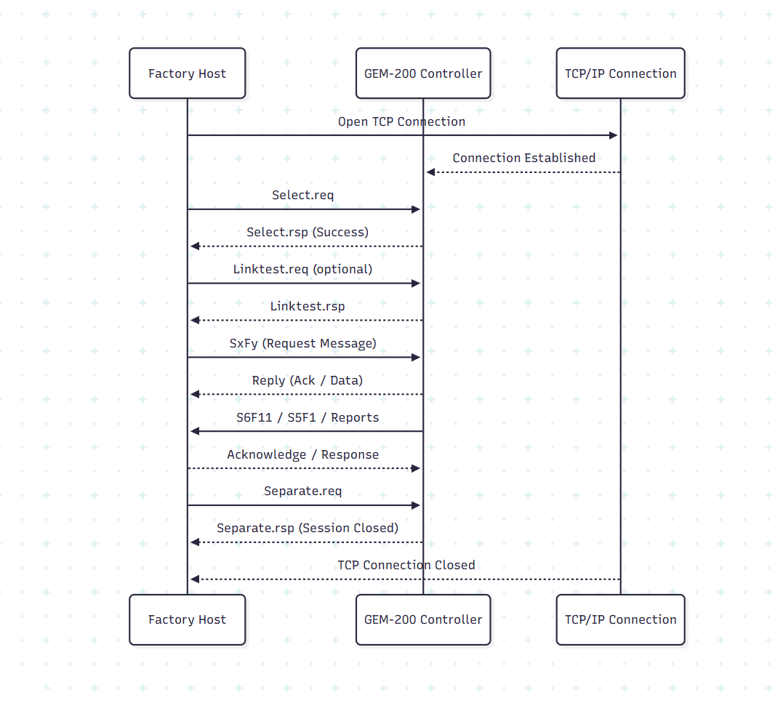

**Figure 1.17 – Interface Design Diagram**

## **Equipment Adapter Interfaces**

* + 1. The Equipment Adapter provides the integration layer between the GEM-200 Controller and the actual equipment control system (PLC, controller, embedded system, etc.).
    2. The interface exposes standardized service calls so that GEM logic can read status, collect data, trigger events, and execute commands without depending on equipment-specific implementations.
    3. All communication between the GEM-200 Controller and the equipment shall be synchronous or asynchronous as required by operation type (e.g., status polling vs. command execution).
    4. The adapter shall support retrieval of equipment status information, including process states, alarms, variable values, and operational health.
    5. The interface shall allow GEM to request execution of commands such as Start, Stop, Reset, Load Recipe, and other OEM-defined functions, while enforcing safety rules implemented at the equipment level.
    6. The adapter shall provide methods to publish equipment events and notifications that map to configured CEIDs for reporting to the Host.
    7. Data provided through the adapter (VID/SVID values, alarms, events, recipe states) must be accurate, current, and consistent with equipment operation
    8. The interface shall isolate OEM-specific control logic so that the GEM-200 Controller remains reusable across different machines.
    9. The Equipment Adapter shall be designed with clear version control, documented APIs, and error logging to simplify maintenance and troubleshooting.

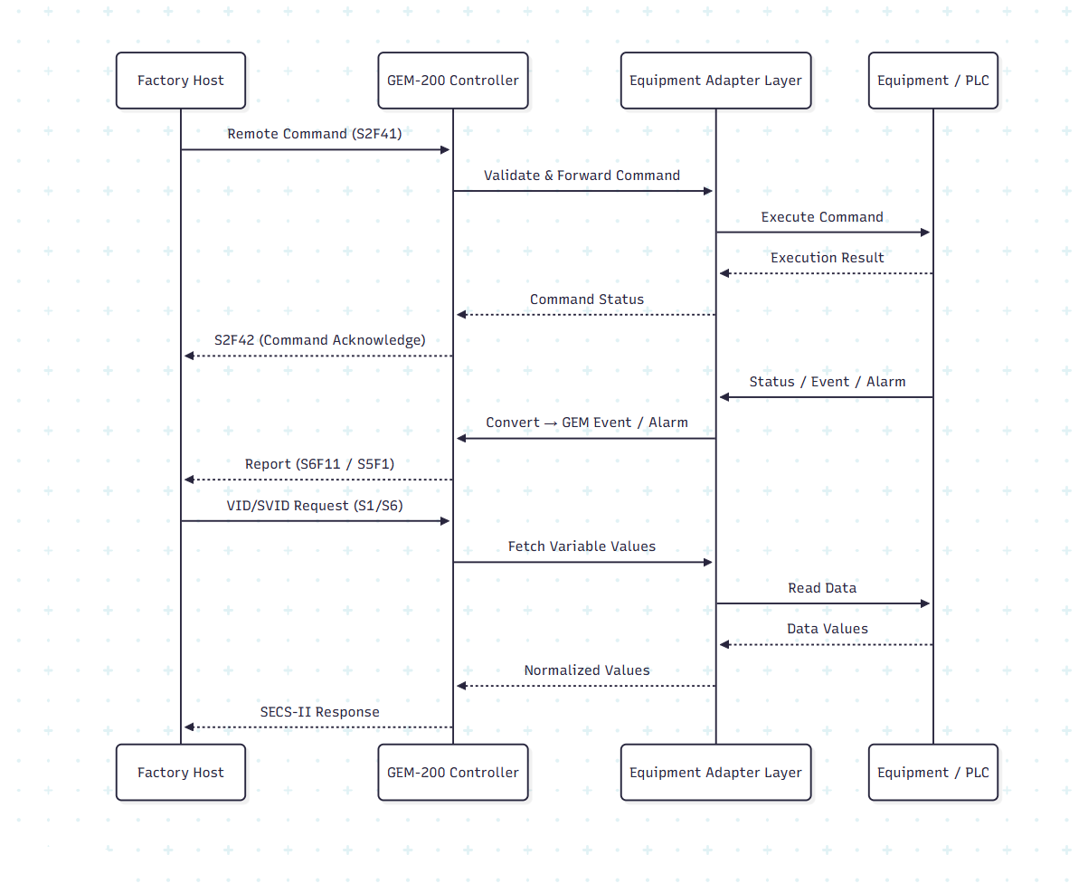

**Figure 1.18 – Equipment Interface Diagram**

## **Interface Protocols and Message Formats**

* + 1. All communication between the GEM-200 Controller and the Host shall follow SEMI E37 (HSMS-SS) as the transport protocol over TCP/IP.
    2. Message content exchanged over HSMS shall conform to SEMI E5 (SECS-II) structure and encoding rules.
    3. SECS-II messages shall use standardized Stream/Function pairs (SxFy) defined in the Supported Message List for events, status queries, remote commands, and report transfers.
    4. Each SECS-II message shall include the correct header fields, including:
    5. Data payloads within messages shall use valid SECS-II item formats such as List, ASCII, Binary, Integer, and Boolean, based on parameter definitions.
    6. Message acknowledgment rules shall be followed strictly, ensuring correct primary/secondary message relationships and timely responses.
    7. Unsupported or malformed message formats shall be rejected with appropriate protocol error responses (S9Fx), with logging for diagnostics.
    8. The controller shall support multi-block message handling where message sizes exceed single-frame limits.
    9. All interface messages shall be traceable through logs, including direction, timestamp, identifiers, and payload summaries.
    10. Any extensions or OEM-specific message formats shall be documented and shall not violate SEMI standard behavior.

# **Communication Error Handling**

## **Communication Error Handling**

* + 1. The system shall continuously monitor HSMS connections for disconnects, timeouts, framing errors, and invalid messages.
    2. When a communication timeout or failure occurs (T3, T5, T6, T7), the system shall log the event and initiate appropriate recovery actions.
    3. If the Host connection is lost, the controller shall automatically attempt reconnection while remaining in a stable offline state.
    4. Invalid SECS-II messages, corrupted frames, or unsupported SxFy messages shall be rejected using the appropriate S9Fx protocol error responses.
    5. Communication failures shall not interrupt internal equipment control; GEM services shall resume automatically when communication is restored.
    6. Link integrity shall be verified periodically using Linktest messages when the Host is connected.
    7. All communication error conditions shall be recorded with timestamps, cause details, and recovery outcomes for diagnostics and audit review.
    8. The system shall ensure that no duplicate, partial, or out-of-sequence messages are processed after recovery.

## Spooling, Replay & Message Recovery

* + 1. The system shall support GEM spooling to temporarily store outbound event, report, and data messages when communication with the Host is unavailable.
    2. When spooling is enabled, messages that cannot be delivered shall be written to a secure, persistent spool queue in chronological order.
    3. Each spooled message shall retain its original timestamp, CEID/RPTID references, and associated variable data.
    4. When communication is restored, the system shall automatically replay spooled messages to the Host in the original order of occurrence.
    5. The Host shall be able to enable, disable, and request delivery of spooled data using standard GEM commands.
    6. The system shall ensure that replayed messages are clearly identified as spooled data to prevent misinterpretation as real-time events.
    7. If the spool storage reaches capacity, the system shall generate an appropriate alarm or error indication without crashing or losing operational control.
    8. Message recovery logic shall guarantee that no events are lost and no duplicate notifications are delivered during replay.
    9. Spool files shall be protected against corruption and preserved across system restarts where configured.
    10. All spooling and replay activities shall be logged, including spool creation, replay attempts, failures, and completion results.

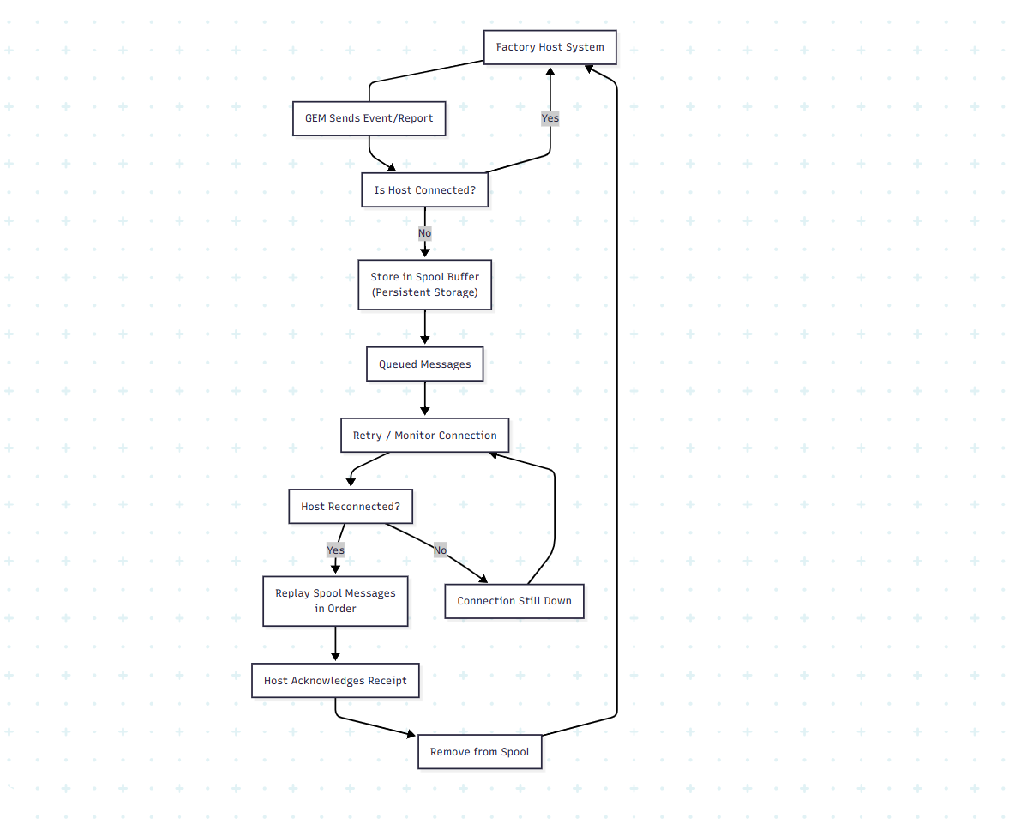

**Figure 1.19 – Spooling Replay & Message Recovery Diagram**

## **Equipment Fault Handling**

* + 1. The system shall monitor equipment health, alarms, and status signals through the Equipment Adapter interface.
    2. Equipment faults shall be classified and mapped to appropriate GEM alarms, events, or status variables as defined in the configuration.
    3. When an equipment fault occurs, the system shall immediately generate the corresponding alarm and/or event notification to the Host.
    4. Fault conditions shall not interrupt GEM communication; the Host must continue to receive status, alarms, and diagnostic information.
    5. Critical equipment faults that impact production shall trigger configurable CEIDs so the Host can take necessary actions.
    6. The system shall ensure that faults remain active until they are explicitly cleared by the equipment and acknowledged as per GEM rules.
    7. If an equipment component recovers from a fault, the system shall generate the appropriate fault-clear alarm or event.
    8. Equipment fault handling shall not automatically execute recovery actions unless explicitly configured or commanded by the Host or operator.
    9. All detected equipment faults, acknowledgments, and clear events shall be recorded in the system logs with timestamps for traceability.
    10. Fault-handling logic shall be designed so that safety-related controls always remain under the equipment’s primary control system (not GEM).

## **Fail-Safe and Recovery Scenarios**

* + 1. The system shall be designed so that any GEM communication failure does not impact equipment safety or process control.  
       Primary safety control shall always remain with the equipment controller/PLC.
    2. If the HSMS session is lost, the system shall automatically transition to the appropriate GEM communication state (e.g., OFFLINE / ATTEMPT ONLINE) and wait for reconnection.
    3. During communication loss, all alarms, events, and reports shall continue to be captured locally (and spooled if enabled) until communication is restored.
    4. When the Host reconnects, the system shall perform a controlled recovery, including:
* Re-establishing HSMS session
* Synchronizing state (Online/Offline, Control State)
* Re-enabling configured reports and traces
* Resuming spooled data delivery (if applicable)
  + 1. If a system restart occurs, the GEM Controller shall restore:
* Last known communication state (where allowed by GEM)
* Enabled events and report configurations
* Alarm active states
* Recipe and configuration information
  + 1. In the event of invalid or corrupted communication, the system shall reject the message, log the error, and continue operating without crashing.
    2. Fail-safe logic shall ensure that:
* No unauthorized remote commands are executed
* No unsafe equipment operations are triggered
* Host commands are acknowledged appropriately (HCACK/ECACK
  + 1. The system shall support configurable retry logic for reconnect attempts and message retransmission where appropriate.
    2. Recovery behavior shall be deterministic and tested under scenarios such as:
* Power loss
* Network failures
* Host restart
* GEM Controller restart
  + 1. All fail-safe and recovery actions shall be logged with timestamps for audit and troubleshooting purposes.

## **Error Logging and Notification Strategy**

* + 1. The system shall provide a centralized logging framework to capture all communication, protocol, and internal processing errors.
    2. Each logged error shall include:
* Timestamp
* Error category (Communication / Protocol / Equipment / System)
* Severity level (Info, Warning, Error, Critical)
* Message description
* Related Stream/Function (if applicable)
  + 1. Errors related to HSMS/SECS communication shall record:
* Connection status changes
* Timeout events
* Invalid or rejected messages
* HSMS/SECS protocol violations
  + 1. Equipment-related faults detected via the Equipment Adapter shall be logged and correlated with alarms or events when applicable.
    2. The system shall support **configurable log retention** and automatic log rotation to prevent storage exhaustion.
    3. Critical system or communication failures shall trigger notifications such as:
* System alerts within diagnostics tools
* Optional email or message-based alerts (if configured by OEM/customer)
  + 1. The logging system shall distinguish between:
* Recoverable errors (retries possible)
* Non-recoverable failures requiring operator intervention
  + 1. All logged errors shall be available for:
* Troubleshooting
* Post-incident analysis
* Compliance audits
  + 1. The system shall avoid exposing sensitive information (passwords, IP keys, etc.) in logs.
    2. Logs shall support filtering by:
* Date/time
* Error type
* Severity
* Component
  + 1. Error notification mechanisms shall be designed so they do not interfere with normal GEM operation or introduce delays.

# **Security & Access Control**

## **Security Objectives**

* + 1. The system shall protect Host–Equipment communication and internal data from unauthorized access, modification, or misuse.
    2. The system shall ensure that only authenticated and authorized users or systems can configure, control, or modify GEM functions.
    3. Sensitive operations (such as configuration changes, recipe handling, and command execution) shall require appropriate authorization levels.
    4. The system shall preserve data integrity across communication, storage, and processing layers.
    5. Security controls shall not interfere with normal production communication or equipment operation.
    6. All security-related actions (logins, configuration changes, failed access attempts, etc.) shall be recorded in secure audit logs.
    7. The design shall follow defense-in-depth principles, ensuring that multiple layers of protection exist across network, application, and data layers.
    8. Security mechanisms shall comply with relevant factory IT, cybersecurity, and OEM policies.
    9. Default system configuration shall follow **secure-by-default** principles, minimizing unnecessary services and exposed interfaces.

## Network & Communication Security

* + 1. The system shall restrict network access to authorized factory networks and approved Host systems only.
    2. HSMS communication ports shall be configurable and protected from unauthorized external access.
    3. HSMS communication ports shall be configurable and protected from unauthorized external access.
    4. All inbound and outbound communication paths shall be documented and limited to required GEM functionality only.
    5. When supported by the deployment environment, secure tunnels (e.g., VPN or encrypted channels) may be used to protect remote diagnostic connections.
    6. The system shall detect and log unusual connection behaviour, including repeated failed connection attempts or abnormal message patterns.
    7. Default network credentials, exposed services, or open ports shall be disabled unless explicitly required.
    8. Communication integrity shall be ensured through protocol validation, message length checks, and strict adherence to SEMI HSMS/SECS standards.
    9. The system shall prevent unauthorized systems from impersonating the Host or injecting invalid SECS-II traffic.
    10. Network security controls shall be designed to operate without disrupting normal GEM communication performance.

## **Authentication & Authorization**

* + 1. The system shall restrict access to configuration, maintenance tools, and diagnostic utilities using user authentication.
    2. User accounts shall be assigned defined roles (e.g., Operator, Engineer, Administrator) with appropriate permission levels.
    3. Only authorized roles shall be allowed to modify GEM configuration, recipes, communication settings, or remote command permissions.
    4. Authentication credentials shall be stored securely and never logged in plaintext.
    5. Failed login attempts shall be detected, logged, and may trigger lockout mechanisms if configured.
    6. Authorization checks shall occur before executing sensitive operations such as:
* Enabling/disabling GEM features
* Managing recipes
* Editing event/CEID mappings
* Running diagnostic or simulation tools
  + 1. Session management shall ensure that inactive administrative sessions automatically expire after a configurable timeout.
    2. Access privileges shall be auditable, with all configuration changes recorded in secure audit logs.
    3. Default user accounts and passwords (if present) shall require change at deployment time.
    4. The system design shall allow integration with external authentication systems (e.g., LDAP/Active Directory) if required by factory IT policy.

## **Security Logging and Auditing**

* + 1. The system shall maintain dedicated audit logs for all security-relevant activities.
    2. The following events shall be recorded at minimum:
* User logins and logouts
* Failed authentication attempts
* Configuration changes
* Role or permission modifications
* Remote command execution activities
* System startup, shutdown, and restart actions
  + 1. Each audit entry shall include:
* Timestamp
* User or process identity
* Action performed
* Result (success/failure)
* Relevant details (e.g., parameter changed, command issued)
  + 1. Audit logs shall be tamper-resistant and protected from unauthorized modification or deletion.
    2. Security logs shall be retained according to configurable retention policies aligned with factory or OEM compliance requirements.
    3. The system shall provide tools or interfaces to review, search, and export audit logs for investigation or compliance review.
    4. Critical security incidents shall generate alerts or notifications where configured.
    5. Audit logging shall operate independently of core GEM processes to avoid interference with real-time communication.
    6. Access to view or manage audit logs shall be restricted to authorized security or administrative roles only.
    7. Security audit functionality shall support external log integration (e.g., SIEM or centralized log servers) where required.

# **Performance & Scalability**

## **Performance Targets**

* + 1. The system shall process standard HSMS/SECS-II requests within acceptable response times under normal operating conditions.
    2. Typical message round-trip latency between Host and equipment shall meet the following objectives (configurable based on deployment):
* Status/variable queries: **≤ 200 ms**
* Event/report notifications: **≤ 300 ms**
* Remote command acknowledgments: **≤ 500 ms**
  + 1. The system shall support continuous communication without message loss under expected factory throughput loads.
    2. The controller shall sustain a minimum message handling capacity suitable for GEM-200 production environments (e.g., bursts of multiple event/report messages without degradation).
    3. Timer-driven mechanisms (T3, T5, T6, T7) shall operate within defined limits to ensure protocol reliability and responsiveness.
    4. Background operations such as logging, configuration updates, and diagnostics shall not significantly impact GEM communication performance.
    5. Performance targets shall be validated under realistic factory scenarios during system testing.
    6. Where hardware limitations affect performance, recommended CPU, memory, and network requirements shall be documented.

## **Connection Handling Capacity**

* + 1. The system shall support a **single active HSMS session** with the Host at any given time, as required for standard GEM-200 operation.
    2. If an existing session is active and a second Host attempts to connect, the system shall reject or queue the connection according to configuration policy.
    3. The system shall automatically transition to a listening state when the Host disconnects, allowing reconnection without manual intervention.
    4. The system shall detect abnormal or half-open network connections and clear them gracefully to prevent blocking communication.
    5. Internal queues shall ensure ordered delivery of messages without duplication or data loss.
    6. In engineering or simulation environments, optional configuration may allow controlled multiple diagnostic or monitoring connections (if implemented), without affecting production mode.
    7. Connection management behaviour shall always remain compliant with SEMI E37 session rules.
    8. Connection capacity limits and constraints shall be documented for deployment planning.

## **Scalability Considerations**

* + 1. The system shall be designed to scale for increased message volume, event frequency, and reporting activity without architectural changes.
    2. Core modules (communication, event processing, logging, and data handling) shall support performance tuning through configuration rather than code modification.
    3. The architecture shall allow deployment on higher-capacity hardware (CPU, RAM, storage) to improve throughput when required.
    4. Internal processing pipelines shall allow asynchronous or parallel execution where appropriate to prevent bottlenecks.
    5. The system shall support expanding configurable limits such as:
* Maximum number of defined CEIDs, RPTIDs, VIDs
* Number of remote commands
* Size and number of stored recipes
  + 1. Optional modules such as simulators, diagnostics, and UI components shall remain isolated so they do not impact production performance.
    2. Logging and audit features shall support off-loading to external storage or centralized log servers for large installations.
    3. Scalability strategies shall be validated during performance and load testing to ensure predictable behaviour under stress.

## **Optimization Strategy**

* + 1. The system shall use efficient message parsing, buffering, and routing techniques to minimize processing overhead during HSMS/SECS communication.
    2. Message handling paths shall be optimized so that frequently used operations (status queries, event notifications, alarms) execute with minimal latency.
    3. Background tasks such as logging, diagnostics, and configuration updates shall operate asynchronously to avoid blocking real-time GEM communication.
    4. Caching mechanisms may be used for frequently accessed values (such as VID/SVID data) where appropriate, ensuring consistency with equipment state.
    5. The system shall provide configurable performance tuning parameters, including message queue sizes, retry intervals, and logging verbosity.
    6. Resource-intensive operations such as recipe transfers, trace collection, and large report generation shall be handled using controlled scheduling to avoid performance spikes.
    7. Performance monitoring metrics shall be collected to evaluate throughput, latency, message loss, and error rates during operation.
    8. Identified performance bottlenecks shall be addressed through incremental tuning without requiring architectural redesign.
    9. Optimization techniques shall always preserve protocol correctness, reliability, and GEM compliance.

# **Testing & Validation Strategy**

## **Test Objectives**

* + 1. The objective of testing is to verify that the GEM-200 Controller meets all functional, performance, and compliance requirements defined in the SRS.
    2. Testing shall validate correct behaviour of communication, events, alarms, reports, recipes, and remote commands under normal and abnormal conditions.
    3. Tests shall confirm interoperability with factory Host systems using HSMS/SECS-II protocols.
    4. The testing process shall identify defects early, ensuring system reliability before deployment on production equipment.
    5. Testing shall verify that failure handling, recovery, and spooling mechanisms operate as designed.
    6. Security testing shall ensure access controls, authentication, and audit functions operate correctly.
    7. Performance testing shall validate latency, throughput, and stability against defined performance targets.
    8. Compliance validation shall ensure alignment with applicable SEMI standards (E30, E37, E5, E4).
    9. Acceptance testing shall confirm that the delivered system meets OEM and factory expectations for production usage.
    10. Test results shall be documented and traceable to corresponding system requirements.

## **Unit & Component Testing**

* + 1. Each software module shall undergo unit testing to verify correct implementation of internal logic and boundary conditions.
    2. Unit tests shall focus on individual functions such as message parsing, state transitions, event generation, VID retrieval, and logging behaviour.
    3. Component testing shall validate that integrated submodules (e.g., HSMS handler + SECS parser) operate correctly as a functional unit.
    4. Mock interfaces or simulators shall be used to emulate Host and equipment behaviour during module testing.
    5. Test scenarios shall include both valid and invalid inputs, ensuring the system handles edge cases gracefully.
    6. Automated testing tools shall be preferred where possible to improve repeatability and coverage.
    7. Component-level defects shall be resolved before proceeding to integration testing.
    8. Unit and component test results shall be documented and maintained as part of the validation record.

## **Integration Testing**

* + 1. Integration testing shall verify that individual modules work together correctly as part of the complete GEM-200 system.
    2. Test scenarios shall validate end-to-end communication flows between:
    3. Integration tests shall ensure proper sequencing and interaction between HSMS communication, SECS-II message handling, and GEM logic.
    4. Special emphasis shall be placed on testing state transitions, including OFFLINE/ONLINE and LOCAL/REMOTE scenarios.
    5. Integration testing shall verify that events, alarms, reports, and VID data are generated and transmitted correctly.
    6. Fault conditions such as disconnects, timeouts, invalid messages, or equipment failures shall be simulated to verify recovery behaviour.
    7. Spooling, replay, and message buffering mechanisms shall be validated under real communication conditions.
    8. Integration tests shall confirm that operator and engineering tools do not adversely affect production communication.
    9. All detected issues shall be documented, analyzed, and corrected before moving to performance and acceptance testing.
    10. Integration testing shall be traceable to system requirements and architecture design decisions.

## **Performance Testing**

* + 1. Performance testing shall verify that the GEM-200 Controller meets defined latency, throughput, and stability targets under expected operating loads.
    2. Test scenarios shall simulate realistic factory traffic, including frequent alarms, events, status queries, and recipe transfers.
    3. Load tests shall measure system behaviour during peak message bursts and sustained communication periods.
    4. Performance tests shall validate that message processing remains within acceptable response times and no data loss occurs.
    5. Performance tests shall validate that message processing remains within acceptable response times and no data loss occurs.
    6. Resource utilization (CPU, memory, disk I/O, and network bandwidth) shall be monitored to ensure efficient operation.
    7. Stress testing shall evaluate system stability under extreme or abnormal conditions such as continuous reconnects, rapid event bursts, or large file transfers.
    8. Long-duration endurance testing shall be conducted to verify reliability over extended production-like operation.

## **Conformance Testing**

* + 1. Conformance testing shall verify that the GEM-200 Controller behaves in full accordance with applicable SEMI standards, including E30 (GEM), E37 (HSMS-SS), E5 (SECS-II), and E4 (message structure).
    2. Standard GEM conformance scenarios shall be executed using recognized GEM testers or certified Host simulators.
    3. Tests shall validate proper implementation of:
    4. Protocol compliance shall include correct stream/function usage, W-bit handling, HCACK responses, and error (S9Fx) message behaviour.
    5. Protocol compliance shall include correct stream/function usage, W-bit handling, HCACK responses, and error (S9Fx) message behaviour.
    6. Conformance testing shall also ensure that unsupported or invalid requests are handled gracefully and in accordance with SEMI rules.
    7. Any deviations discovered during conformance testing shall be analyzed, corrected, and retested prior to system release.
    8. Successful completion of conformance testing shall be a prerequisite for factory qualification and acceptance.

## **Acceptance Criteria**

* + 1. The GEM-200 Controller shall be accepted only after all functional, performance, and reliability requirements defined in this document are successfully verified.
    2. All high-priority and critical defects identified during testing shall be resolved, retested, and closed prior to acceptance.
    3. Conformance testing shall demonstrate compliance with SEMI E30, E37, E5, and related standards without functional deviations.
    4. The system shall demonstrate stable Host communication, correct GEM state transitions, and reliable event, alarm, and report handling under normal and recovery conditions.
    5. The controller shall pass integration testing with the factory Host, including recipe flows, remote commands, data collection, and terminal services.
    6. Performance benchmarks (latency, throughput, message handling, and reconnect behaviour) shall meet or exceed documented targets.
    7. Security verification shall confirm configuration protection, access restrictions, and secure communication behaviour where applicable.
    8. Installation, configuration, backup, and recovery procedures shall be documented and validated.
    9. Final acceptance shall require formal approval from stakeholders, including Engineering, QA, and the Customer (or Factory Integration team).

# **Deployment & Maintenance**

## **Deployment Architecture**

* + 1. The GEM-200 Controller shall be deployed as a standalone software application running on a dedicated industrial PC or server connected to the equipment network.
    2. The controller shall communicate with the factory Host system using HSMS-SS over TCP/IP.
    3. The controller shall connect to the equipment control system through the Equipment Adapter interface (e.g., PLC API, OPC, proprietary interface, or middleware).
    4. Configuration files, logs, recipes, and persistent data shall be stored in secure local or network-based storage, depending on deployment policy.
    5. The deployment shall support both **single-system installations** (one controller per equipment) and **centralized monitoring setups** where multiple tools connect to a supervisory Host.
    6. Network architecture shall separate equipment control, factory IT, and administrative access networks where applicable, to ensure security and isolation.
    7. The system shall support redundancy options such as data backup, log retention, and spool replay to improve reliability and recovery.
    8. Remote access for diagnostics and maintenance shall be controlled, authenticated, and restricted based on factory security policies.
    9. Deployment shall allow upgrades and patches to be applied without disrupting active GEM communication whenever possible.
    10. The deployment design shall support monitoring tools for health checks, performance metrics, and fault notifications.

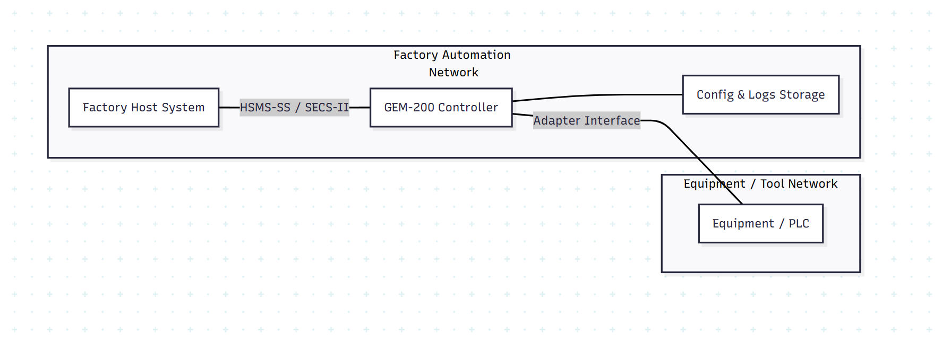

**Figure 1.19 – Deployment Architecture Diagram**

## **Installation & Upgrade Procedure**

* + 1. The installation package shall include the GEM-200 Controller software, configuration templates, documentation, and validation tools.
    2. Installation shall be performed on a validated industrial PC or server that meets the specified hardware and operating system requirements.
    3. Installation shall be performed on a validated industrial PC or server that meets the specified hardware and operating system requirements.
    4. Initial configuration files (alarms, events, reports, VID/SVID definitions, recipes, etc.) shall be imported and verified before enabling live communication.
    5. After installation, the system shall undergo a basic connectivity test with the Host and the equipment to confirm HSMS communication and adapter linkage.
    6. The upgrade process shall support version-to-version deployment with minimal disruption to production operation.
    7. During upgrades, existing configuration, logs, recipes, and historical data shall be preserved unless explicitly replaced.
    8. During upgrades, existing configuration, logs, recipes, and historical data shall be preserved unless explicitly replaced.
    9. All upgrades shall be validated through functional smoke testing before being released for production use.
    10. Installation and upgrade activities shall be documented, version-controlled, and approved by the responsible engineering and QA stakeholders before sign-off.

## **Backup & Restore Strategy**

* + 1. The system shall support periodic backups of critical GEM-200 data, including configuration files, recipes, logs, and event/alarm history.
    2. Backups shall be stored in a secure, configurable location such as local storage, network storage (NAS), or factory backup servers.
    3. Backup schedules (daily, weekly, manual) shall be configurable to align with factory IT policies and operational needs.
    4. Backup schedules (daily, weekly, manual) shall be configurable to align with factory IT policies and operational needs.
    5. The restore mechanism shall allow recovery of configuration, recipes, and operational data without requiring full software reinstallation.
    6. Restore operations shall validate compatibility between backup versions and the currently installed software version to prevent corruption.
    7. In case of hardware replacement or system failure, the GEM-200 Controller shall be restorable to the last known working state using backup data.
    8. Backup files shall be protected against unauthorized access, modification, or deletion through appropriate access controls.
    9. Backup and restore activities shall be logged for auditing and troubleshooting purposes.
    10. Periodic restoration drills or validation tests shall be performed to ensure reliability and readiness of the recovery process.

## **Monitoring & Health Checks**

* + 1. The system shall continuously monitor the health and operational status of the GEM-200 Controller and its core modules.
    2. Health checks shall include monitoring of communication status, process heartbeat, resource usage (CPU, memory, disk), and critical service activity.
    3. The system shall detect and report abnormal conditions such as connection loss, message queue buildup, timer violations, and internal processing failures.
    4. A periodic heartbeat signal shall be maintained to confirm that the GEM-200 Controller is active and responsive.
    5. Health status and alerts shall be logged and optionally exposed through diagnostic interfaces or APIs for factory monitoring tools.
    6. In the event of health check failures, predefined recovery actions (restart modules, reconnect, trigger alarms) shall be automatically initiated where safe and applicable.
    7. Monitoring status information shall be retained for troubleshooting, performance tracking, and audit analysis.
    8. Monitoring status information shall be retained for troubleshooting, performance tracking, and audit analysis.

## **11.5. Maintenance & Support Guidelines**

* + 1. The GEM-200 Controller shall be designed to support routine maintenance activities with minimal production disruption.
    2. Maintenance tasks shall include log review, configuration verification, software updates, backup validation, and monitoring of system health indicators.
    3. The system shall provide clear diagnostic information to assist engineering and service teams in troubleshooting issues.
    4. Support procedures shall define escalation paths, roles, and responsibilities between OEM engineering, service teams, and customer support.
    5. All maintenance activities shall be documented, including software changes, configuration updates, and corrective actions performed.
    6. Preventive maintenance guidelines shall recommend periodic checks for communication stability, alarm/event behaviour, recipe handling, and data storage capacity.
    7. Remote service access (if allowed) shall follow security controls and customer approval processes
    8. Maintenance tools, simulators, and diagnostic interfaces shall be used only by authorized personnel.
    9. Maintenance tools, simulators, and diagnostic interfaces shall be used only by authorized personnel.
    10. Any updates or fixes deployed to the GEM-200 system shall be validated in a staging or test environment before being applied to production.

# **Appendices**

## **Architecture Diagrams**

* + 1. The appendices shall include high-level architecture diagrams to visually illustrate the GEM-200 Controller design and interactions.
    2. Diagrams shall provide clarity on relationships between modules, interfaces, and external systems, supporting both engineering and client understanding.
    3. The following diagrams shall be included (as applicable):
* **System Context Diagram** – Shows Host, Equipment, Controller, and external interfaces.
* **Logical Architecture Diagram** – Shows internal software layers and components.
* **Deployment Architecture Diagram** – Shows where components run (server, network, equipment).
* **Component Interaction Diagram** – Illustrates message and data flows between modules.
* **Data Flow Diagram** – Describes movement of alarms, events, recipes, commands, and logs.
  + 1. Each diagram shall include labels, legends, and short descriptions to ensure it can be understood without prior system knowledge.
    2. Any future architectural enhancements shall be reflected by updating the diagrams as part of controlled version management.

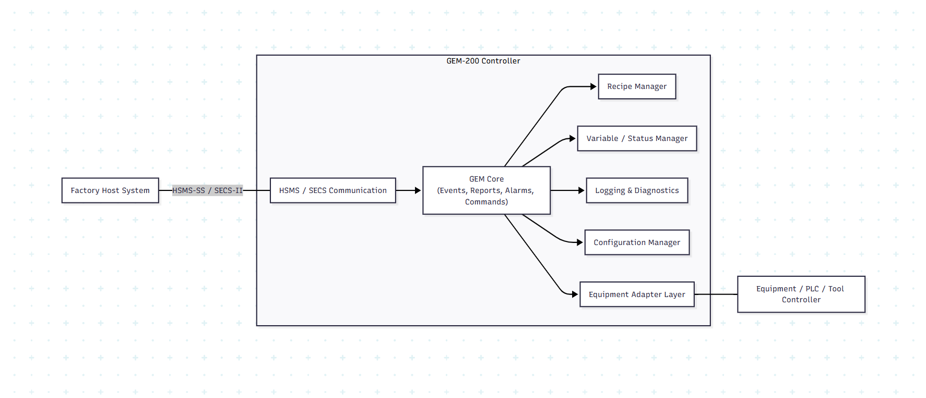

**Figure 1.20 – Architecture Diagram**

## **Sequence Diagrams**

* + 1. The SDD shall include sequence diagrams to illustrate step-by-step interactions between the Host, GEM-200 Controller, Equipment Adapter, and Equipment.
    2. Sequence diagrams shall help visualize runtime behaviour, message flow, and timing relationships for critical scenarios.
    3. The following key use-cases shall have sequence diagrams documented:
* **HSMS Session Establishment**

Host connects, Select.req/Select.rsp exchange, communication ready state.

* **Remote Command Execution**

Host sends S2F41, validation occurs, command routed to Equipment Adapter, S2F42 reply.

* **Alarm Generation & Reporting**

Equipment alarm triggered, GEM alarm engine updates state, S5F1 sent, Host acknowledgement.

* **Event Reporting (S6F11)**

CEID triggered, report generated, VIDs collected, S6F11 sent to Host.

* **Recipe Upload / Download**

Host uploads or requests recipe, validation, storage, acknowledgement flow.

* **Trace / Periodic Data Collection**

Host configures trace, system collects values, scheduled S6F1/S6F2 reporting.

* **Reconnect & Recovery Scenario**

Connection lost, session timeout, reconnection flow, pending operations handling.

* + 1. Each sequence diagram shall clearly show:
* Participants (Host, GEM Controller, GEM Modules, Equipment Adapter, Equipment)
* Direction of messages (with SECS function names where relevant)
* Decision points (validation, state checks)
* Success and error paths (where applicable)
  + 1. Sequence diagrams shall be aligned with implementation behaviour to avoid design mismatches.
    2. Changes to interaction logic shall require corresponding updates to the diagrams as part of design change control.

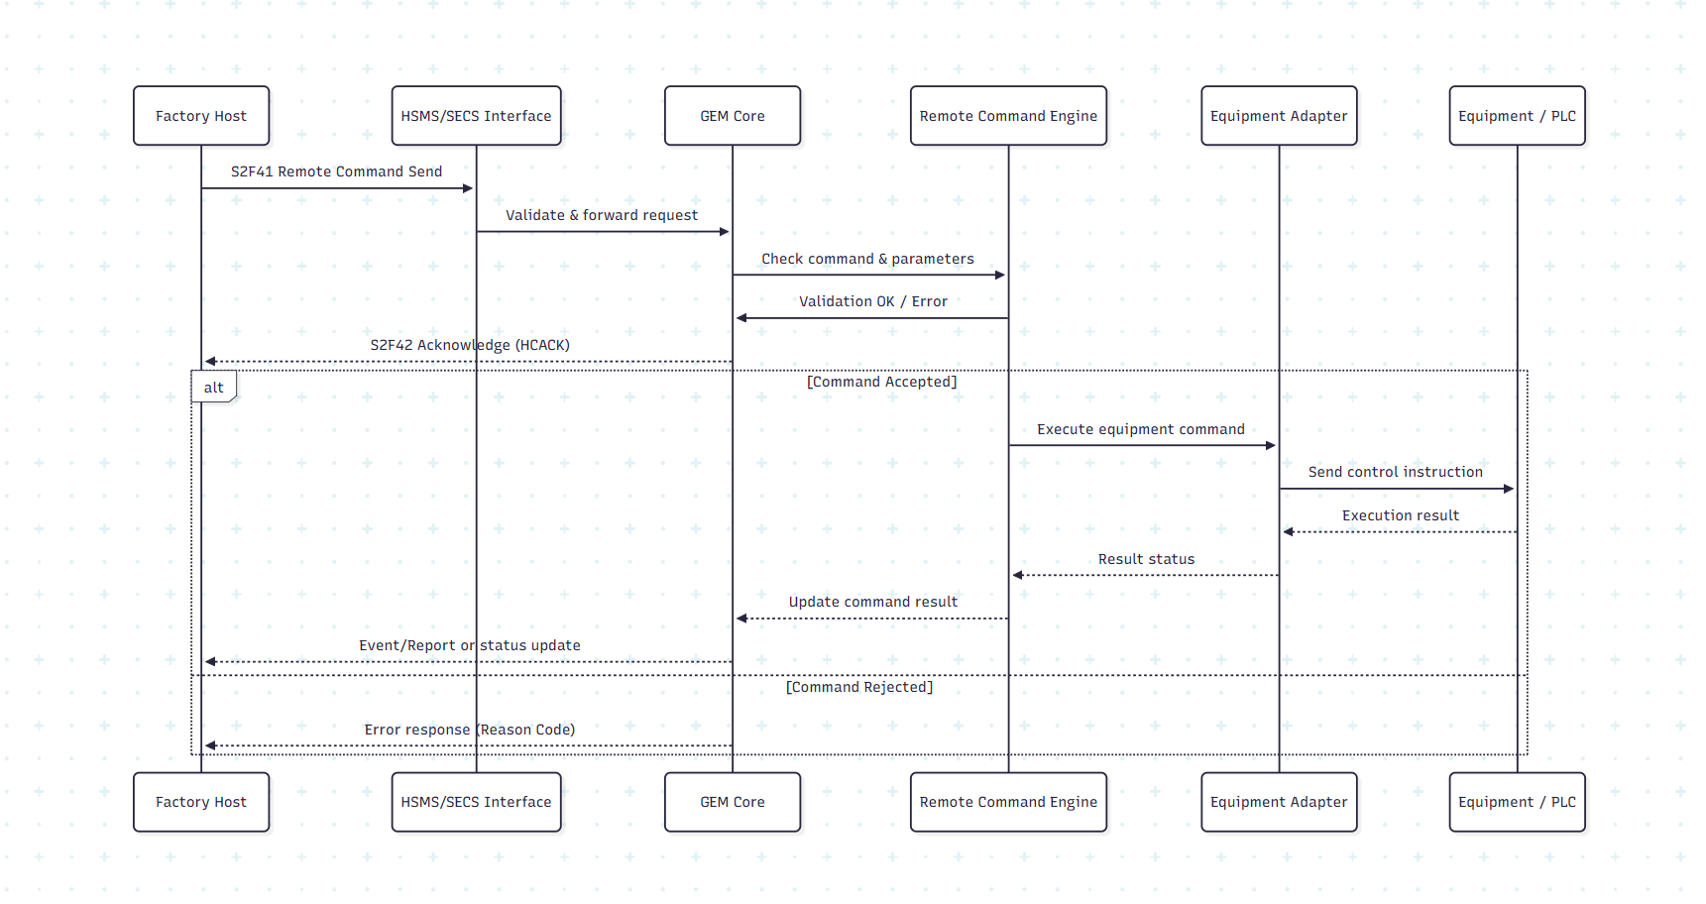

**Figure 1.21 – Sequence Diagram**

## **Class Design**

* + 1. **IGemFacade (Controller Facade)**
* Acts as the central entry point for all GEM functions.
* Exposes services for alarms, events, recipes, variables, and commands.
* Manages HSMS communication and message routing.
* Provides consistent APIs for integration.
* Simplifies maintenance by hiding internal complexity.
  + 1. **GemEngine (Facade Implementation)**
* Implements IGemFacade and coordinates GEM behaviour.
* Initializes and manages all GEM service components.
* Starts and stops HSMS communication sessions.
* Dispatches SECS-II messages for processing.
* Tracks communication and online state readiness.
  + 1. **IGemInterface (Equipment Adapter Interface)**
* Defines the integration contract between GEM and the real equipment.
* Provides identity, software revision, and equipment time.
* Exposes variables, alarms, recipes, and diagnostics.
* Reports communication establish/loss events.
* Allows reuse of the GEM controller on different tools.
  + 1. **Equipment State Component (IEquipmentStateComponent)**
* Manages Local / Remote control states.
* Tracks process state (Running, Paused, Stopped).
* Controls process transitions safely.
  + 1. **Variable Component (IVariableComponent)**
* Maintains defined VIDs and SVIDs.
* Supports read/write of equipment variables.
* Generates change notifications for reporting and trace.
  + 1. **Alarm Component (IAlarmComponent)**
* Maintains defined alarms and current alarm states.
* Raises and clears alarms based on conditions.
* Notifies GEM for Host alarm reporting.
  + 1. **Recipe Component (IRecipeComponent)**
* Manages recipe list and metadata.
* Supports upload and download operations.
* Handles recipe selection, activation, and deletion.
  + 1. **Remote Command Component (IRemoteCommandComponent)**
* Stores supported remote command definitions.
* Validates incoming command requests.
* Executes commands through equipment safely.
  + 1. **Diagnostic Component (IDiagnosticComponent)**
* Provides CPU, memory, and system temperature data.
* Supports troubleshooting and maintenance diagnostics.
* Enhances system health monitoring.
  + 1. **Overall Design Benefits**
* Clear separation of GEM logic and equipment logic.
* Easy reuse across multiple equipment platforms.
* Better maintainability, scalability, and testing.



**Figure 1.22 – Class Design**

## **Glossary**

This glossary defines key terms used in the GEM-200 System Design Document to ensure consistent understanding across engineering, QA, and customer teams.

|  |  |  |
| --- | --- | --- |
| **Term** | **Full Form / Meaning** | **Description / Usage in GEM-200** |
| GEM | Generic Equipment Model | SEMI standard defining equipment-to-host communication behaviour, states, alarms, events, and control. |
| HSMS-SS | High-Speed Message Service – Single Session | TCP/IP-based communication protocol used between Host and Equipment (SEMI E37). |
| SECS-II | Semiconductor Equipment Communication Standard – II | Defines message structure, streams, functions, and data formats used in GEM (SEMI E5). |
| CEID | Collection Event ID | Identifies events that the Host can subscribe to and receive reports for. |
| RPTID | Report ID | Logical container that groups variables sent when an event occurs. |
| VID | Variable ID | Data value (process/status/measurement) reported to Host. |
| SVID | Status Variable ID | Special type of VID representing equipment status values. |
| RCMD | Remote Command | Host-initiated command executed by equipment (e.g., START, STOP). |
| HCACK | Host Command Acknowledge | Status returned by equipment indicating remote command acceptance or failure. |
| ALID | Alarm ID | Unique identifier assigned to each alarm condition. |
| CE | Collection Event | A monitored condition that triggers report generation. |
| W-bit | Wait-bit | Indicates whether a reply message is expected by the Host. |
| DeviceID | Device Identifier | Logical ID representing the equipment instance in communication. |
| System Bytes | Transaction Identifier | Used to correlate request and response messages. |
| DERC | Dynamic Event Report Configuration | Mechanism allowing Host to dynamically configure reports and events. |
| Recipe | Process Program | Set of parameters defining how the equipment processes wafers/parts. |
| Spooling | Store-and-Forward Messaging | Temporary storage of messages during connection loss for later replay. |
| Online / Offline | Communication Modes | Defines whether Host-Equipment communication is enabled or disabled. |
| Local / Remote | Control Modes | Determines whether operator or Host controls the equipment. |
| FAT | Factory Acceptance Testing | Testing performed at customer site before production use. |
| Equipment Adapter | Integration Layer | Software interface connecting GEM logic to real equipment control systems. |

## **Future Enhancements**

* + 1. The design shall allow incremental feature expansion without major architectural changes.
    2. Future releases may include enhanced reliability features such as priority-based spooling and advanced replay logic.
    3. Additional analytics features may be added to support historical trace visualization and data export.
    4. Recipe management may be extended with full version governance, approval workflows, and rollback capability.
    5. Security enhancements may introduce role-based access control (RBAC) and stronger configuration protection.
    6. High-availability deployment support may be introduced using redundant controller configurations.
    7. Support for Dynamic Event Report Configuration (DERC) may be added to allow more flexible Host-driven reporting.
    8. Clock synchronization may be enhanced using external NTP/PTP services for tighter timestamp accuracy.
    9. Online identification workflows may be improved to better support automation during communication transitions.
    10. A web-based engineering console may be added for diagnostics, logs, configuration, and testing.
    11. External REST APIs may be introduced for integration with factory analytics and supervisory systems.
    12. Dedicated Host and Equipment Simulators may be provided as standalone tools for FAT and testing.
    13. Scenario-based simulation capability may be added to support automated test cases for alarms, events, and process sequences.
    14. Additional logging capabilities may include structured JSON logs, central aggregation, and live streaming.
    15. Future enhancements shall be reviewed and prioritized based on customer requirements and SEMI standard updates.